
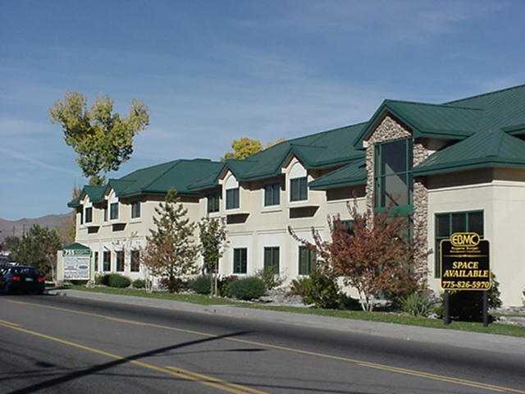

Professional Office

755 N. Roop Street

Carson City, Nevada 89701



Address: 755 N. Roop Street, Carson City, NV 89701

Type: Office/Therapy

Size: 2,486 – 2,803 ±SF

Floor: 1st and 2nd Floors

Rate: $1.50 PSF Full Service

Attributes: Property is located at Hwy 50 E and Roop Street; building is adjacent to city bus line; functional floor plans with beautiful mountain views; abundant parking; move-in ready suites; free rent and/or tenant improvement allowance.

Immediate Occupancy

For more information please contact:

Kelly A. McKenzie 5011 Meadowood Mall Way, Ste. 200
Commercial Division Manager Reno, NV 89502
Tel: 775-826-5970 www.ebmc.com
Cell: 775-560-4169
kellysiefert@ebmc.com
Lic # S.50045
Professional Office - Suite 211/2,803 SF
Professionally built out office with reception, 9 private offices, conference room and bullpen area. Suite is available via elevator service.

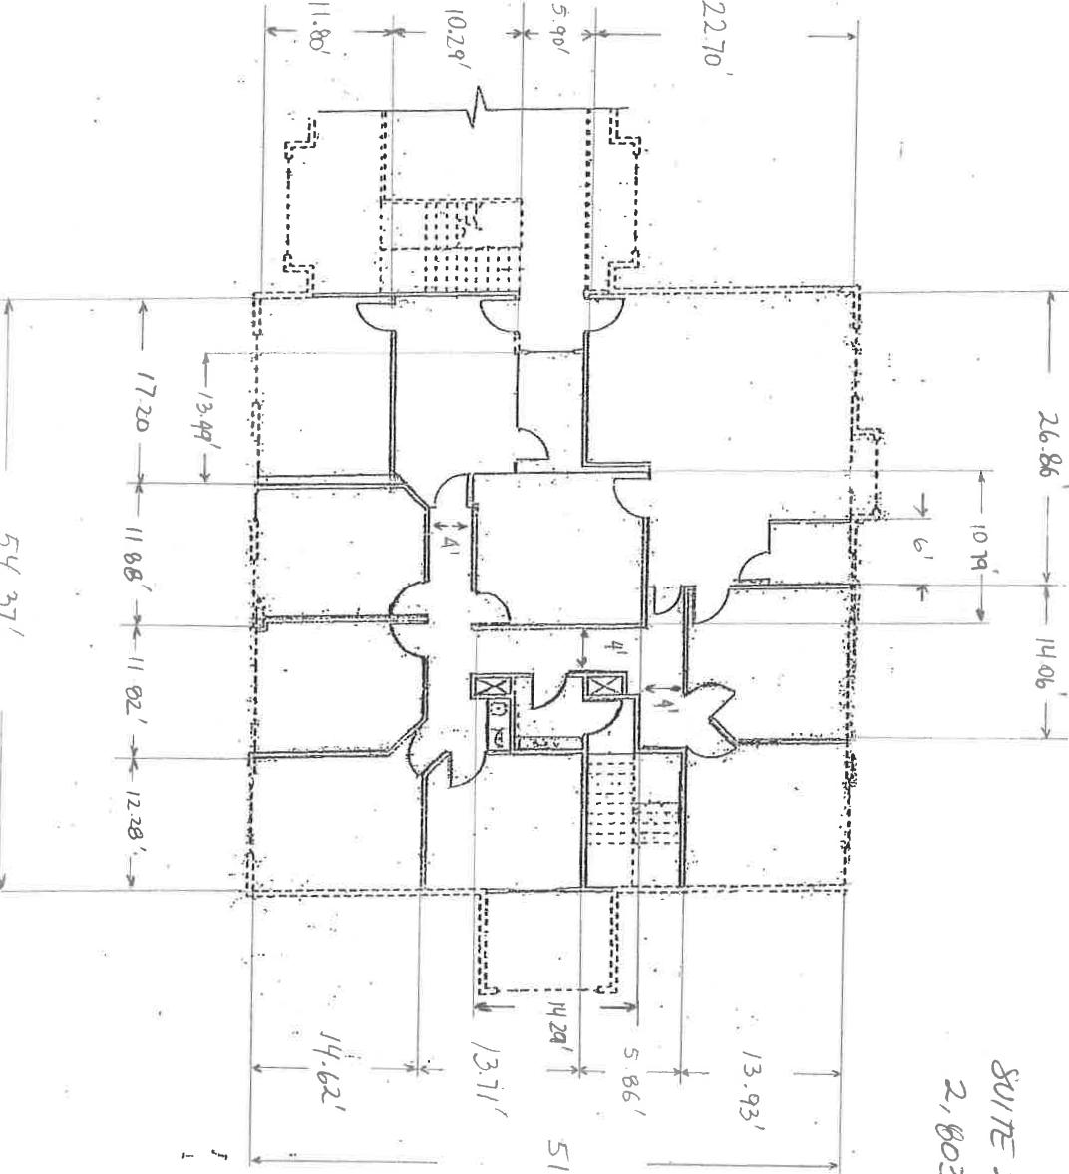
Medical/Therapy Suite - 107/2,486 SF
Former physical therapy office with 2 private offices, break room, storage room and large reception/waiting area. Suite is equipped with connections for a washer/dryer and hydro room. Great 1st floor access.
