FreerCrossingsCommerceCenter Submission FINANCING PHASE II:
﻿
﻿
﻿
﻿Banks

first American bank
USA Century Bank,
Ocean Bank
Eastern international savings and loan Association
amarant
Grove Bank and Trust
space coast
FIRST AMERICAN BANK, MR. EGLAND

General contractor candidates
KMHR.
CW
AJB.

Construction set of values (tentative) $3M

SUB CONTRACTORS / TRADE ITEM

CCTV SECURITY CAMERAS - existing FCCC

on site supervision -FCCC partial

no PERMANENT ladder NECESSAY

Shell construction
$913,000

.

CIVIL SITE WORK, drainage, foundation, striping,
bumpers provided by owner,
signage,, footers

JBA
395k

ELECTRICAL SUBCONTRACTOR
$295,000.

PLUMBING SUBCONTRACTOR,
WALTERPLUMBING CORP.
$54,000.
Incl. Faucets, grab bars, toilets, drinking fountains, mop, sinks, mirrors, tissue paper dispensers, toilet, paper, dispensers

.
Lawn irrigation $9000

Dumpster enclosure fencing $4000

Owner to furnish the gates for the dumpster enclosure

Rough carpentry was included in the labor

painting $45,000 exterior
general liability insurance $40,000
Surveyor, $2500.
Bathroom tile $5000

stucco contractor. $42,000.
General labor $60,000 ?

Rough carpentry $13,000

thermal insulation $4500

mechanical for exhaust fans and fart fans,

fire caulking,
fire exit LIGHTS
extinguishers,

landscaping materials - South Miami LANDSCAPE, Nursery
TREES.
These numbers might be excessive
/PINE. NINE.
LIVE OAK 10
MANOLA POEM 4
Mango five
gumbo limbo three
cabbage palm one

SHRUBS

FIRE BUSH 185
SILVER SAW PALMETTO 185

soil treatment, termite ,
$4200.

twin t.
core Slab, SPI,
$302,000.

precast, specialties,

framing, drywall, baseboards, $30,000.

glazing windows,and doors, $67,000 impact resistant

steel doors, $18k.?

overhead doors. $44,000.

JB garage doors

All-American garage doors

Soil boards were performed by Winger or laboratories

bifold doors for the mop sink enclosure,
Cleaning by owner. $10,000

fire caulking $2000.
interior doors, $40,000
Baseboards $4500
No Porta potties needed FCCC Bay Three will allow the use of its bathroom and offices.
Three storage trailers material

LOPEFRO dumpsters will be utilized
Roofing
ADA hardware $3500.
roofing, $211,000
Hilton Roofing Heights Roofing, Poe Roofing

SUB contractor
insurance.

erosion, earthwork Rock power paving

Excavation quicksand

Patriot windows $74,000

drywall and framing $32,000

Striping and paving would be included under civil work
irrigation and sprinklers frosty

coreslab miami.com
SPI Miami and precast specialties

electrical contractor
$295,000.

Souza paint

Bathroom floor and wall tile
$9000
ADA bathroom, accessories,
Mailbox

drywall framing,

insulation and wall finish

exterior paint,
$72,000

joint protection

FINANCING PHASE II﻿

FreerCrossings CommerceCenter
.
FCCC HAS $15M EQUITY IN THE PROPERTIES.

"LATEST SET OF PLANS" , FreerCrossings CommerceCenter Phase II (12554 - 12582 Southwest 128th Street, 33186) 21,000 sf office/warehouse building with 22-24' high twin T roof.

AUGUST UPDATE - FCCC PHASE II

FreerCrossings CommerceCenter Phase II

Please see the Dropbox link below for all corrections made per county comments:

Dropbox Link

Thank you,



Respectfully,

Cinthia Avila Dubon
Robert Barnes & Associates
Phone (305)247-6150
cinthia@robertbarnesassociates.com
221 N. Krome Ave, Homestead, Fl.33030

"The details are not the details. They make the design." – Charles Eames

Freer Crossings Commerce Center is the owner developer at
12554 - 12582 Southwest 128th Street, Miami, Florida 33186.

LOCATED IN AFFLUENT WEST KENDALL, MILE WEST OF THE TURNPIKE AND S.R . 874, A MILE EAST OF THE EXECUTIVE AIRPORT.

Subject: DRIVING WEST ON 128 STREET TO FCCC

https://youtube.com/watch?v=qpMmSz1fHF4&feature=shared

The inspections will be done monthly by David Santamaria, P.E.,
a structural engineer, and will do the inspections of the progress of the construction.
His family is a tenant in the current Phase 1,
with a business called Alpha Performance Group, 12596 SW 128 Street,
which provides volleyball coaching for high school girls.

The permit is finalized except for the fact that the attorney Richard Krinzman will finalize the opinion of title once we've got the financing lined up.
Then all of the disapproval comments will have been resolved with the Miami-Dade County Building Department for the final permit.

FREER & SONS INDUSTRIAL DEVELOPERS
(786) 201-1415

12590 Southwest 128th Street, Suite 400
FreerCrossings CommerceCenter
Miami, Florida 33186

Phase II is to be a 21,000 square foot office warehouse building with 22-24 foot high ceilings, twin T roof.

FreerCrossings CommerceCenter PLAN? sell condominium OFFICE/ WAREHOUSE SUITES FCCC PHASE II
﻿

FREER & SONS INDUSTRIAL DEVELOPERS, LLC or Corporation TBD

FreerCrossings CommerceCenter Condominium Association, LLC

12588 Southwest 128th Street, bay unit 3

Miami, Florida 33186

B, A, & K Group, Inc.
Architects-Engineers-Land Surveyors
12000 SW 92 Street, Miami, FL 33186 email: engineercontractor@gmail.com
Phone: (786) 488-1000

January 10, 2024

Building Official
Miamidade County
Building Department
11805 SW 26th Street
Miami, FL 33175

Re-certification of Buildings, Per Dade County Ordinance#75-34;
Structural and Electrical Re-certification of Building at 12584 SW 128 ST, Miami FL 33186
40 years certification for folio # 30-5913-003-0010

Building Official

Based on my evaluation and attached certification reports of the aforementioned
property, this building is structurally sound and the electrical installation is safe for
continued use and occupancy.
As routine mater, in order to avoid possible misunderstanding, nothing in this report
should be construed directly or indirectly as a guarantee for any portion of the
installation. To the best of my knowledge and ability, this report represent an accurate
appraisal of the present condition of the building based upon careful evaluation of the
observed conditions, to the extent reasonable possible.
Should you require additional information regarding this inspection, please feel free to
contact the undersigned.

Yours truly,

B, A, & K Group, Inc.
Joseph Chan, PE, PSM, CGC

.

BEST LOCATION IN FL!

WATCH THE VIDEO.

https://youtu.be/qpMmSz1fHF4?si=xZsNeJbZFk8JdCtr

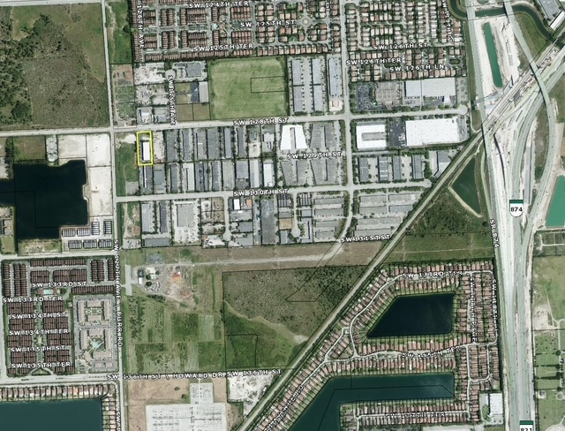

C.

D.

PHOTO OF BAY 6

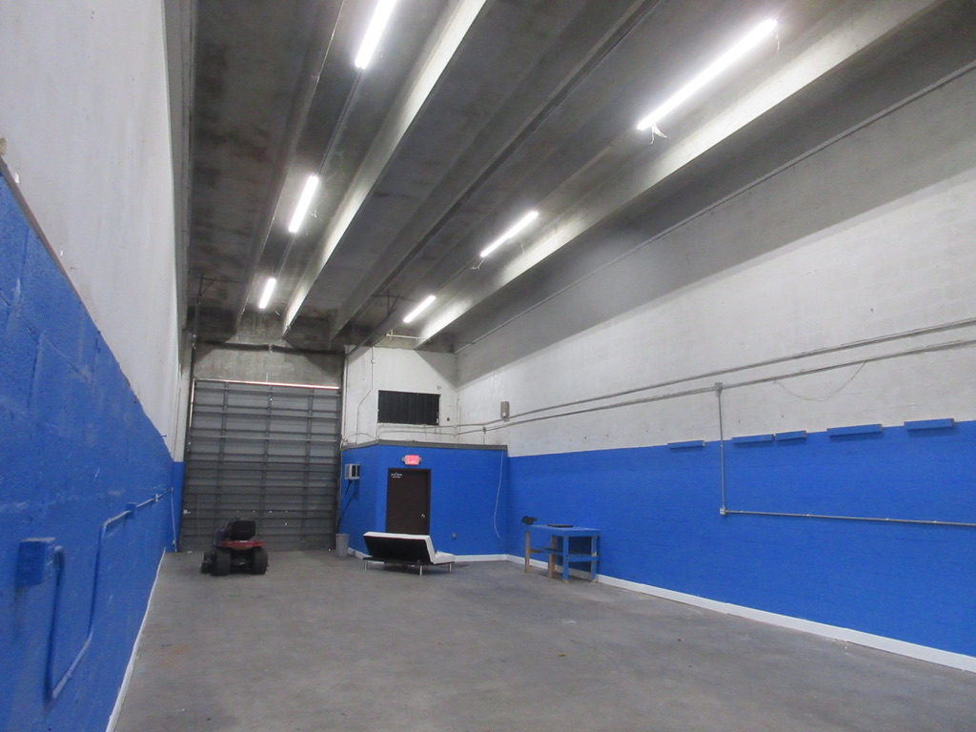

https://chatgpt.com/s/t_68902e1ae0408191b3a140d5f5e72266

PERSONAL FINANCIAL STATEMENTS
Richard Harris Freer
David Chester freer
FREER & SONS INDUSTRIAL DEVELOPERS
(786) 201-1415
12588 Southwest 128th Street, Suite 300
FreerCrossings CommerceCenter
Miami, Florida 33186

Ocean Bank CD and checking account will be sent.

Richard Harris Freer

FREER & SONS INDUSTRIAL DEVELOPERS
(786) 201-1415

12588 Southwest 128th Street
FreerCrossings CommerceCenter
Miami, Florida 33186
Begin forwarded message:

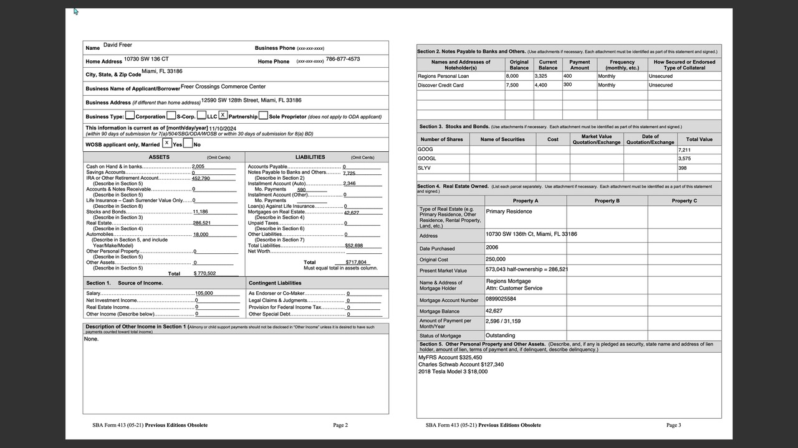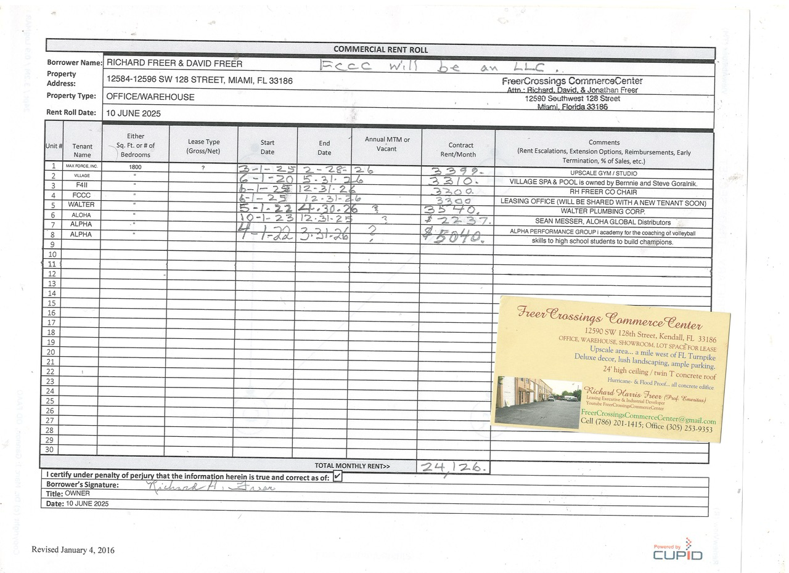

Good morning
Hope you are healthy and prosperous.

A.

FOR LEASE

BAY FOUR & / OR BAY SIX

OF THE FREERCROSSINGS COMMERCECENTER CONDO ASSOCIATION

I.E. 12590 SW. 128TH ST. AND 12594 SW. 128TH ST. RESPECTIVELY

AT THE RATE OF $3300./MO. FOR 1760 FT.

BAY FOUR FEATURES

A FINISHED AND FURNISHED 10 X 20 OFFICE AND A 10 X 15’ OFFICE,

ALONG WITH THE LAUNDRY SINK OR MOP SINK

A BATHROOM IN THE REAR OF THE BAY.

DIMENSIONS ARE 25 X 70

BAY SIX FEATURES A 10 X 15 OFFICE WITH THE BATHROOM AT THE REAR WALL.

DIMENSIONS OF EACH BAY ARE 25’ X 70’.

. BOTH BAYS ARE EQUIPPED WITH PALLET RACKS, HEAVY DUTY SHELVING, FILE CABINETS, DESKS AND CHAIRS.

10. Certificate of a Surveyor and Mapper

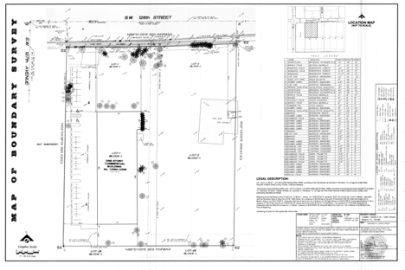

- Verifying that unit boundaries are accurately described
- Compliance with Chapter 718.104(4)(e), Florida StatutesIf we opt for a Declaration of Condominium conversion

(Freer Crossings Commerce Center – Phase 1I)
a Declaration of Condominium (the “Declaration”) will be made.
FREER & SONS INDUSTRIAL DEVELOPERS
(786) 201-1415
12588 Southwest 128th Street, Suite 300
FreerCrossings CommerceCenter
Miami, Florida 33186 (the “Developer”).
1. Recitals

FCCC has prepared a draft of the prospectus and documents.
NOTICE OF INTENDED FCCC PHASE II CONDOMINIUM CONVERSION

🏗 Part 1 — Conversion Plan (Florida, Chapter 718, Part VI)

📘 PROSPECTUS / OFFERING CIRCULAR
1. General Description
- Introduction to FreerCrossings CommerceCenter
- Strategic location in West Kendall, FL 33186
- Class-A warehouse-office design
2. Project Overview
- Total number of units: 7 warehouse/office bays
- Unit sizes: [bays 1 to 6 are 1,760 sq ft and bay 7 is 3,520 sq ft]
- Zoning classification (IU-C “industrial controlled”)
- Delivery condition (finished office space)
3. Developer Information
FREER & SONS INDUSTRIAL DEVELOPERS
(786) 201-1415
12588 Southwest 128th Street, Suite 300
FreerCrossings CommerceCenter
Miami, Florida 33186
- Real estate track record
- Contact information
4. Amenities and Features
- Private office buildout options
- 12’ x 12’ overhead garage doors
- Impact windows
- Security lighting
- Ample parking
- Fiber-ready
5. Maintenance and Association Fees
- Budget summary
- Breakdown by unit size
- 6. Use Restrictions
- Permitted uses (e.g., professional, light industrial, storage)
- Prohibited uses (e.g., automotive repair, noise-producing trades)
7. Sales Process
- Deposit and escrow instructions
- Final closing terms
- Sample contract included in addenda
8. Resale Rights & Disclosures
- Right of first refusal (if any)
- Resale and rental limitations
- Disclosures required under Florida law
9. Contact and Sales Office Info
FreerCrossings CommerceCenter Sales Office
•
FREER & SONS INDUSTRIAL DEVELOPERS (786) 201-1415
12588 Southwest 128th Street, Suite 300
FreerCrossings CommerceCenter Miami, Florida 33186 Website:
📎 Attachments:
- Declaration of Condominium
- Survey
- Floor Plans
- Articles & Bylaws
- Budget
- FAQ Sheet

- The exact address and legal description of the property 30 5913 003 0020
- There are 9 units/bays in Phase 1I
- The names of the owners/developers - Freer Crossings Commerce Center – Phase 1 •
FREER & SONS INDUSTRIAL DEVELOPERS
(786) 201-1415
12588 Southwest 128th Street, Suite 300
FreerCrossings CommerceCenter
Miami, Florida 33186
4.
- The current property manager is Richard Freer.

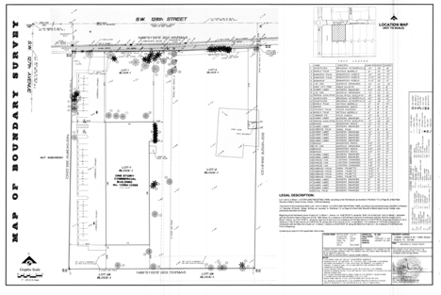

- SINCERELY,
- FREER & SONS INDUSTRIAL DEVELOPERS
(786) 201-1415
12588 Southwest 128th Street, Suite 300
FreerCrossings CommerceCenter
Miami, Florida 33186

