UNIVERSITY BLVD. BUSINESS CENTER

500-510 NW UNIVERSITY BLVD PORT ST. LUCIE, FL 34986
OFFICE WAREHOUSE FLEX SPACE

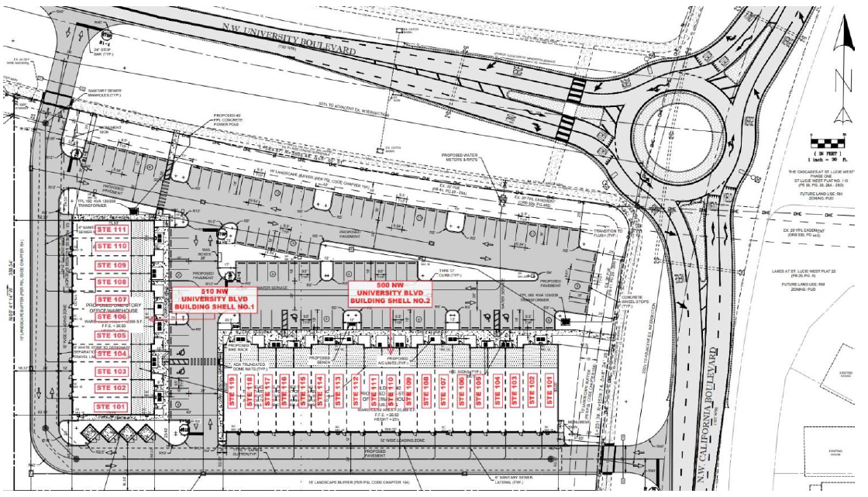
Conveniently located off I-95 in St. Lucie West. Each unit includes a finished air-conditioned office, half bathroom, impact glass windows, with a 10-foot grade-level roll-up door in the rear.
Single unit sizes start at 1,200 total sf.
Water and Trash is included, tenant only pays for Power and Internet NO CAM FEES. First Month, Security and Insurance COI moves you in.
PLEASE CONTACT: gpkmanagement@outlook.com or call 561-743-7381

