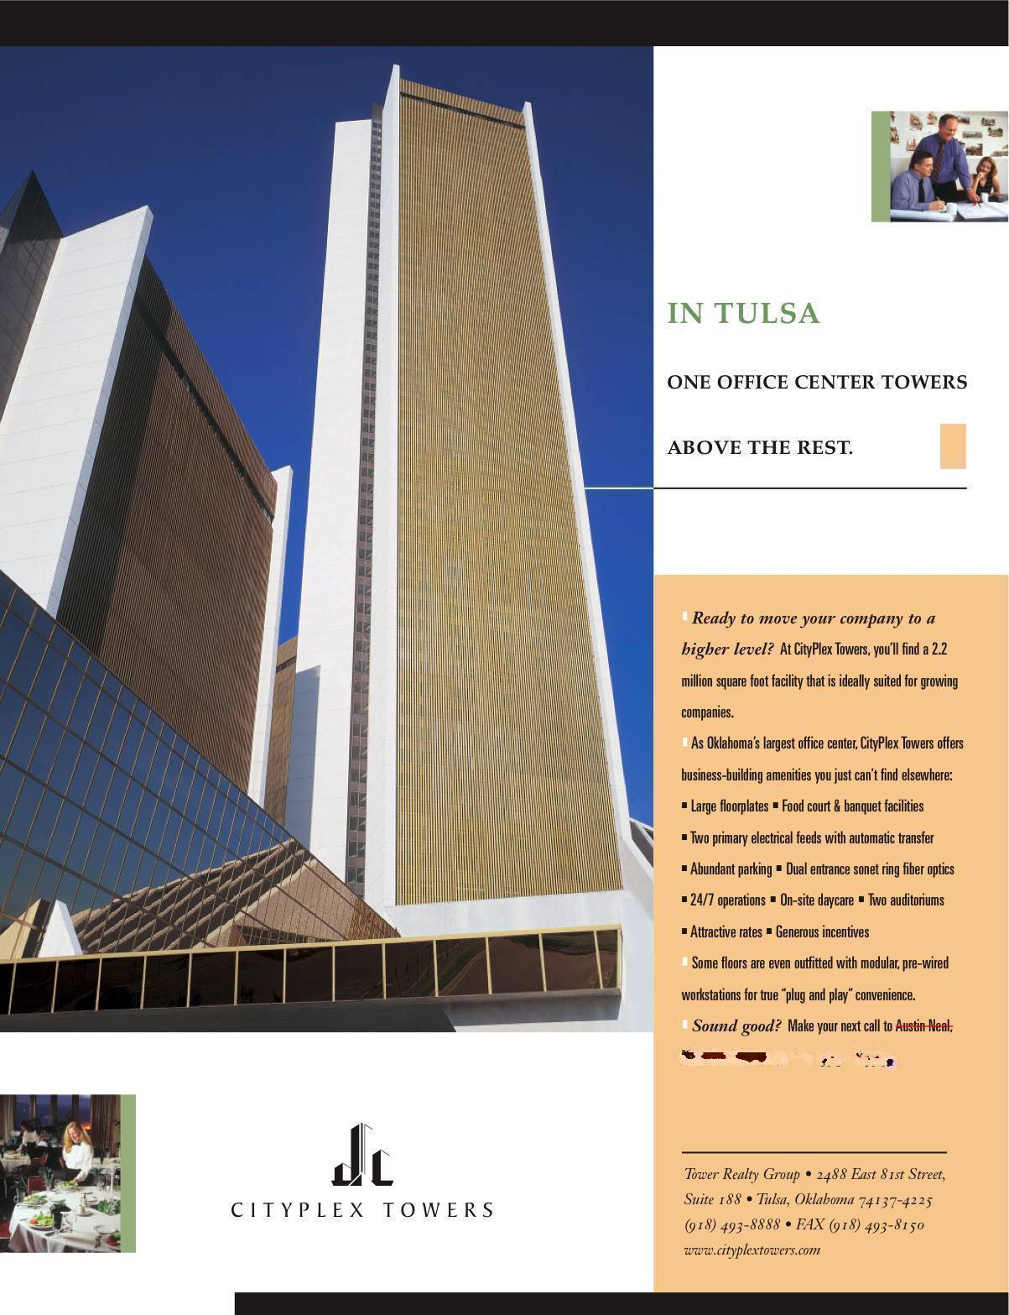

CityPlex Towers
At A Glance

The Towers

At CityPlex Towers, you will discover a three building complex (a 60-story central tower flanked by a 30-story building to the west and a 20-story on the east) that has rapidly evolved into one of the Midwest’s leading office centers. State-of the art technology, innovative interior designs, and atypical amenities have combined at a prime south Tulsa location to offer an exceptional business-building atmosphere for growing companies just like yours.

Location

Located adjacent to CityPlex Towers are hotels, upscale shopping and the campus of Oral Roberts University. Southern Hills Country Club, host of the 2001 U.S. Open, is two miles north. Directly across from CityPlex and the Arkansas River is Oklahoma’s busiest airport, Jones Riverside, which features parallel runways – one 5,101 ft., the other 4,707 ft. – and several FBO and charter aircraft firms. Tulsa International Airport is 25 minutes away.

Arriving at a gateway of higher expectations

In our central 60-story tower, an expansive multistory lobby awaits to greet your guests. This serves as one of the primary throughfares to the adjacent towers and banks of over fifty elevators and escalators. **Starting January ’07, we are undergoing a complete renovation of the lobby. This will include the addition of a credit union, a café, an immense skylight, indoor fountain, etc. This new, impressive entry will be complete 2Q ’07.

Porte-cochere entryways on either side of the main tower afford drive-through convenience year ‘round.

Employees will find abundant on-site parking available at three parking lots that surround our three building complex.

Presenting workspace to take your company to a higher level

CityPlex Towers offers a variety of highly functional office settings that range from small suites to complete floors. The interiors are especially advantageous for call center or IS center operations.

Power: Two separate PSO substations serve CityPlex with auto switching. In the event one substation goes off-line the project automatically switches to the other substation. The delay in the auto-switch is approximately four (4) seconds. There are three (3) 500KW back-up generators that are automatically activated to provide emergency lighting in the event power from both substations are interrupted. There are three (3) 10,000-gallon fuel tanks for the generators.

Communications: Dual entrance sonet ring fiber optics are available on-site. Voice services are provided by a Nortel Meridian 1 telephone system. This system offers advanced features including voice mail and primary rate ISDN. An on-site Southwestern Bell technician is available for any installation or service needs. As a tenant of CityPlex, you get the advantage of advanced technology without the worry of day-to-day operations.

CityPlex has a structured cable plan that is made up of copper cable and multi-mode fiber. We can provide a full array of data services for your LAN and WAN requirements, including equipment and wiring. We offer consulting, network design, installation and maintenance services.

Going to new heights in executive style

The interiors of CityPlex Towers lend themselves to stylish lobbies that can make an impressive statement about your business. Full floor tenants can even create reception areas with direct elevator access.

Flexible floor layouts – common to all three buildings – provide many opportunities for small meeting rooms and multipurpose suites.

Providing amenities of a higher dimension

Meeting/Training Facilities: Auditorium #1 seats 325, #2 seats 125 and #3 seats 75. Over twenty thousand (20,000) square feet of meeting facilities accommodates from five (5) to four hundred (400) people. Use of these rooms are no cost for our tenants. Each facility has a stage, sound system, and a control room for multimedia presentations. Audio/Visual rentals are available through CityPlex Catering and Conference Center.

Security: On site security guards twenty-four (24) hours a day, seven (7) days a week, including holidays. Interior and exterior video surveillance system monitored on-site. Electronic security systems to control after hours access to the project and access within the project. Tenants may tie in to this system to control and monitor access to and within their premises.

Health Club: A newly remodeled, 30,000 square foot, fitness facility with an indoor 1/7 mile tartan surface running track, work-out equipment and locker rooms for men and women. Use is no charge to tenants.

Day Care: Two early learning day care centers are located on-site. Open to the public.

Food Services: An on-site food court and grill serve breakfast and lunch, weekdays. A separate coffee shop and convenience store operate all day. A new café will be added in the newly remodeled lobby and is scheduled to be in operation 2Q ’07.

Catering Services: CityPlex Catering and Conference Center, winner of GTR’s Silver Award for Tulsa’s Best Caterer, provide catering services throughout the building. As well as handling receptions, fundraisers, social and corporate dinners in the Atrium or 60th floor; the Catering and Conference Center can provide you with danish and coffee for ten in your conference room, 300 for a training seminar or a Christmas party for 400.

Banquet Facility: An 11,000 square-foot banquet and meeting facility is located on the 60th floor of our central tower. This facility can handle in-house catered events for 400 guests.

Sixtieth Floor: Tulsa’s best view is available on the 60th floor through CityPlex Catering and Conference Center. The 11,000 square foot banquet/meeting/ballroom facility can provide in-house catered banquets for 400.

Management & Maintenance: CityPlex Towers is staffed for 24-hours a day operations, seven days a week, including holidays.

Life Safety: CityPlex is totally sprinkled. The project is monitored for fire safety through a Simplex system monitored twenty-four (24) hours per day on-site.

Electrical Service and Generator Backup: The CityPlex Towers electrical services are fed from the Tulsa AEP/PSO Delaware Substation. This substation is designed as a dual feed full service substation. The substations primary feeder voltage is 165KV with each feeder being fed from different generation locations and sources. Each of the two transformers inside the Delaware substation feeds it’s own distribution equipment line-up at 15KV. CityPlex Towers owns three (3) circuit breakers within the substation, one in each of the distribution line-ups and one used as a tie. If either one of the dual feeds experiences an outage within three to five seconds the breaker which experienced the problem will open and the tie breaker will automatically close to restore power to both CityPlex feeders.

The two parallel 15KV feeders leaving the substation are installed underground in concrete encased raceways all the way from the substation to the CityPlex Westinghouse WLI dual main distribution switchgear located outside the CityPlex Complex. The dual fed WLI switchgear equipment is again designed with automatic main switches including a tie switch with five to seven second automatic transfer switching. Each 15KV feeder through the automatic main switches feeds it’s half of the dual fed WLI fusible switch line.

Located in the main building, east of the boiler room are the buildings four dual fed substations and related switchgear. Each of the eight 15KV to 5KV or 480-volt oil filled transformers within the vault has manual operated double through 15KV primary switches. Each switch has the capability to be placed on feeder one or feeder two. Each substation line-up will have one transformer selected to feeder one and the other selected to feeder two during normal operation. Three of the four substations are 480 volt and the fourth is 4,160 volt. On the secondary side of each of the six 480-volt substation transformers is a 4,000 amp main fusible automatic switch. Each switch feeds a 4,000 amp common buss through the distribution switchgear with a third 4,000-amp manual or automatic tie switch in the center.

Fusible switches within the switchgear are connected along the 4,000-amp buss on both sides of the tie feed the 480-volt building loads. The 4,160-volt dual feed substation has similar redundancy and feeds the four (4) centrifugal chillers and two spare switches.

The CityPlex Towers complex has three (3) 500 KW Diesel Generators located indoors with up to 30,000 gallons of stored fuel in underground tanks. All three generators synchronize together to produce one 2,000 amp 480-volt emergency system. The emergency switchgear and transfer switches are set up on a priority system of 1, 2 or 3. If only one generator comes on line only priority 1 switches may transfer. If two generators come on line both priority 1 and 2 switches may transfer. With all three generators on line all switches not locked off may transfer if a loss of power is detected.

