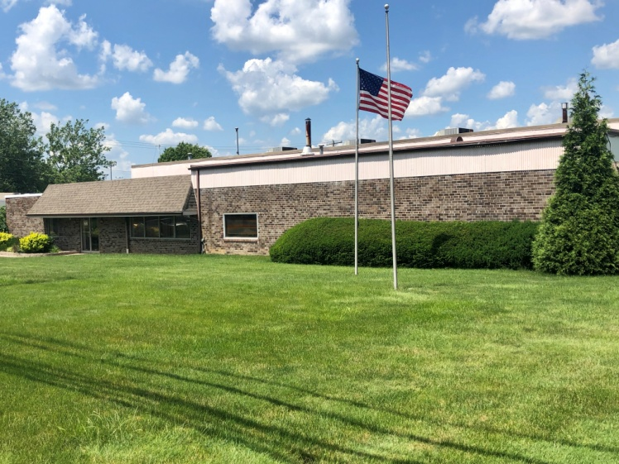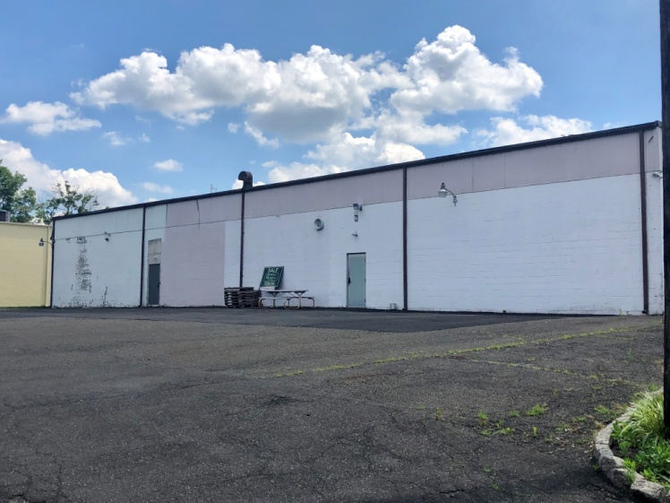

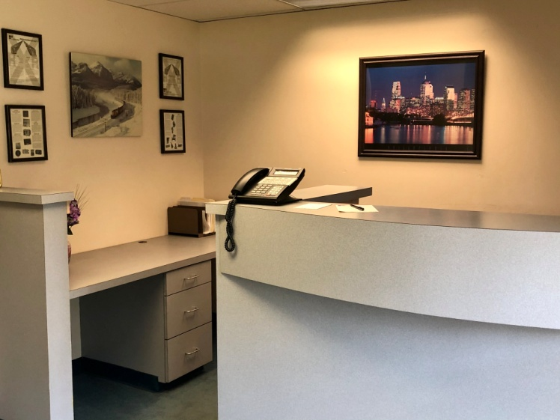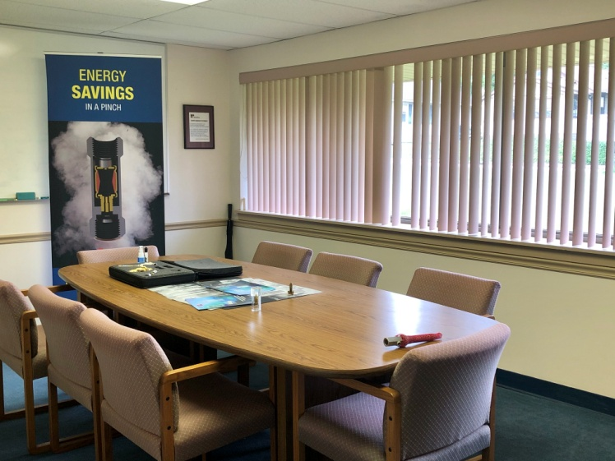

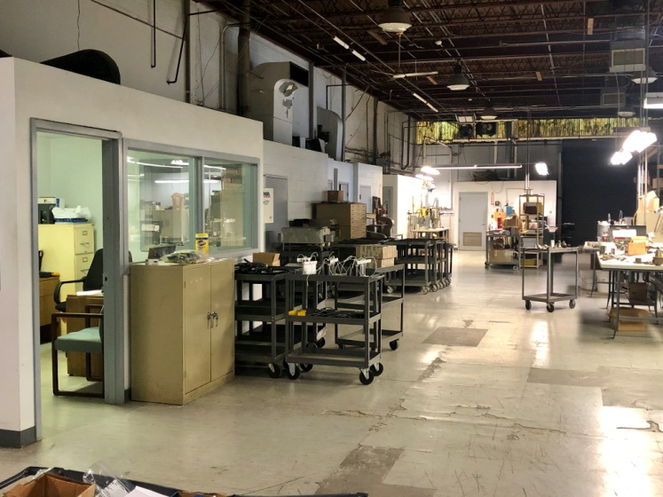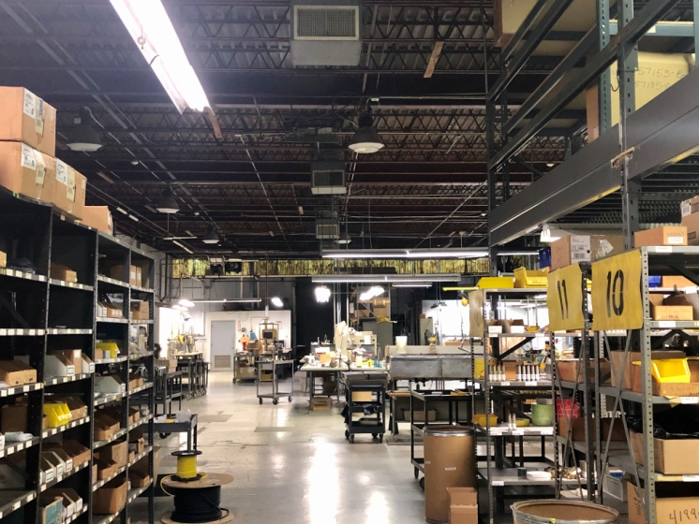

FOR RENT
Great Opportunity!
2835 Terwood Road, Willow Grove
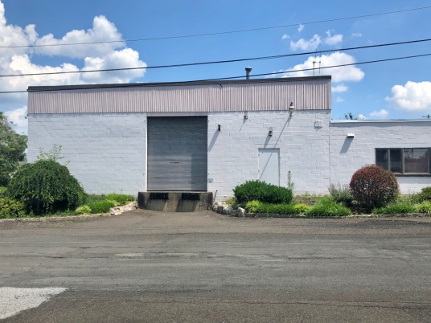
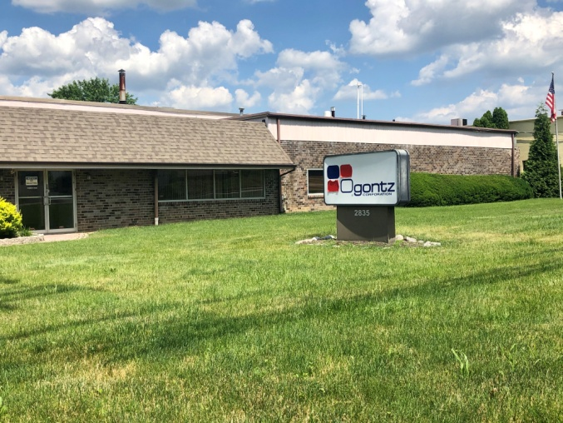

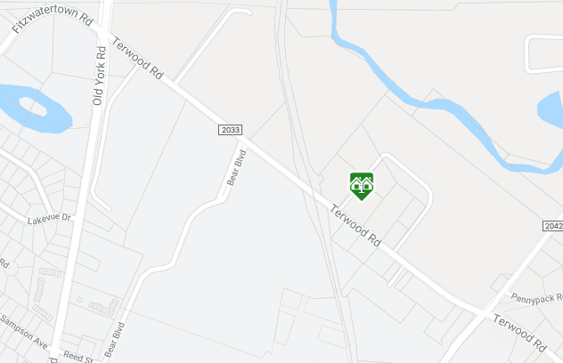
Property Features
For Additional Information,
Please Contact:

Henry Jacquelin
Office: 215.885.7600
Cell: 215.530.5076
Email: hjacquelin@quinnwilson.com



Great Opportunity! Modern Industrial building in prime location. 9,680 square feet, with 30% offices and 70% shop area. The building includes a welcoming lobby/reception area, conference room, copy room, kitchen, 3 restrooms, 15 offices, and a large warehouse space. Property offers plenty of parking, plus a loading dock. Easy to access, just minutes from the Pennsylvania Turnpike, Rt. 611 and Rt. 263. Contact agent for details.

Zoning
- S - Small Limited Industrial Districts

Location
- Excellent Exposure
- Convenient Location

Taxes
- $21,029.00 for 2024

No warranty or representations, expressed or implied, is made as to the accuracy of the information contained herein, and same is submitted subject to errors, omissions, change of price, rental or other conditions, withdrawal without notice, and to any special listing conditions imposed by our principals

No warranty or representations, expressed or implied, is made as to the accuracy of the information contained herein, and same is submitted subject to errors, omissions, change of price, rental or other conditions, withdrawal without notice, and to any special listing conditions imposed by our principals

