WAREHOUSE SPACE FOR RENT – 1160 N. FARM ROAD 123, Suite 108

Location: Northwest Springfield near the new Partnership Industrial Center West; one-quarter mile south of Division on east side of Farm Road 123 (Westgate) and one mile from I-44 interchange at Chestnut Expressway.

Building: 5,000 SF of a 100’ x 200’ = 20,000 square foot building with 25’ x 100’ bays; 24’ eave height; two 9’ x 10’ dock door with Never Lift dock leveler at rear of building; one drive-in door that is 12’ x 12’ on front of building; sprinklered; 6” concrete floor; 3-phase electrical; Plenty of room for truck maneuvering and parking. There is 125’ of asphalt at the back of the building. Built in 2006.

Office: 400 SF (8%) with one handicapped accessible bathroom
(10’x15’ entry office plus 10’x12’ private office)

Rental: $3,437.50 per month ($8.25 per SF on an annual basis)

NNN Lease: Tenant pays utilities, real estate taxes $380 per month or $0.91 per sf, building insurance $100 per month or $0.24 per sf; and CAM ($167 per month or $0.40 per sf): water and sewer, lawn maintenance, parking lot snow removal, and exterior maintenance. Tenant pays direct for trash, interior maintenance, sidewalk snow removal. Landlord is responsible for structure and roof.

Zoning: HM (Heavy Manufacturing)

Contact: ericrobertsmai@aol.com
Eric Roberts, Owner/Broker-Salesperson Joe Roberts, Owner/Broker
1300 West Poplar Street, Suite 200, Springfield, MO 65802
Cell Phone: 417-844-5530 Phone: 417-881-1533x2 Fax: 417-881-1540

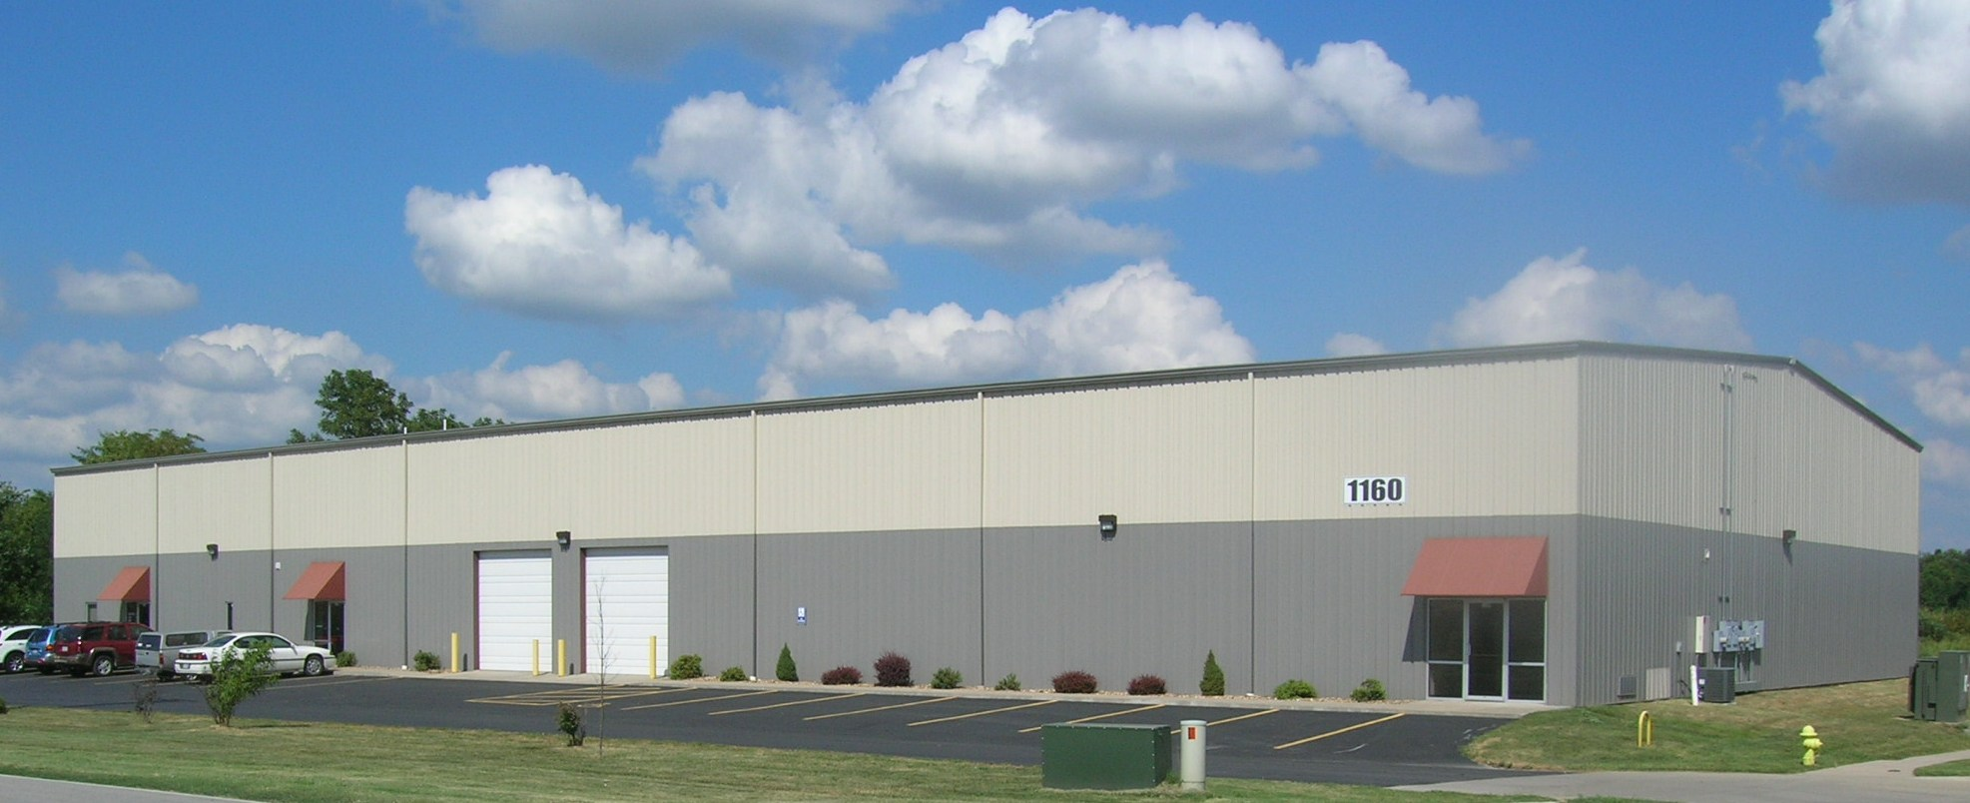

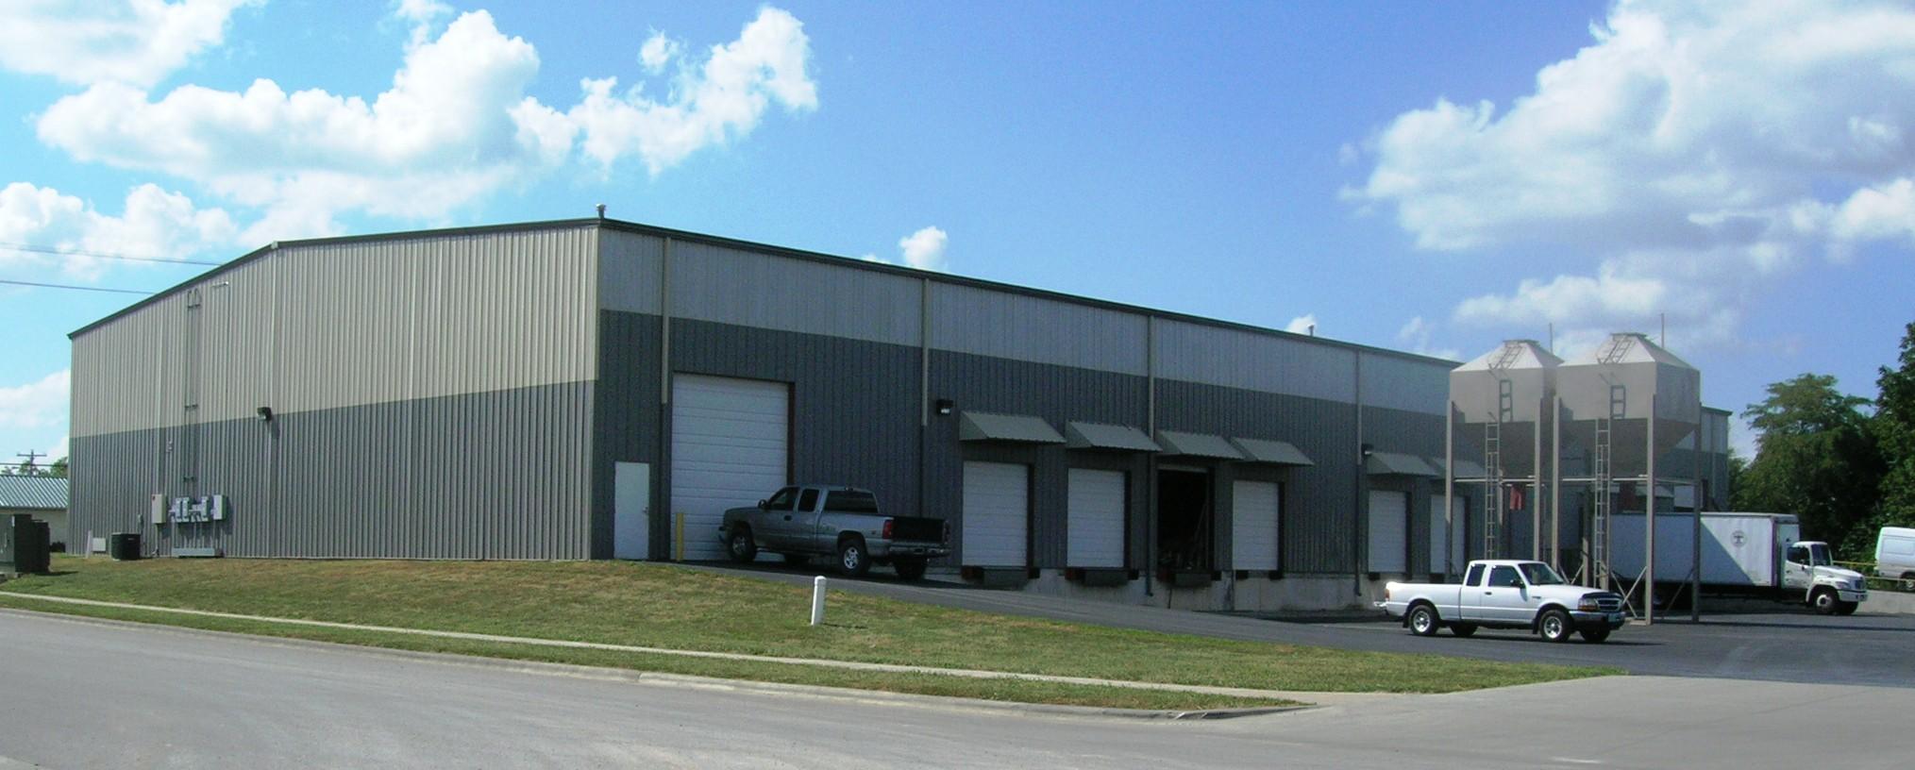
The above information is subject to errors and change.

