Offering Memorandum

For Lease – Former Republic Steel Industrial Facility

2800 E. Dunes Hwy Gary, Indiana 46403
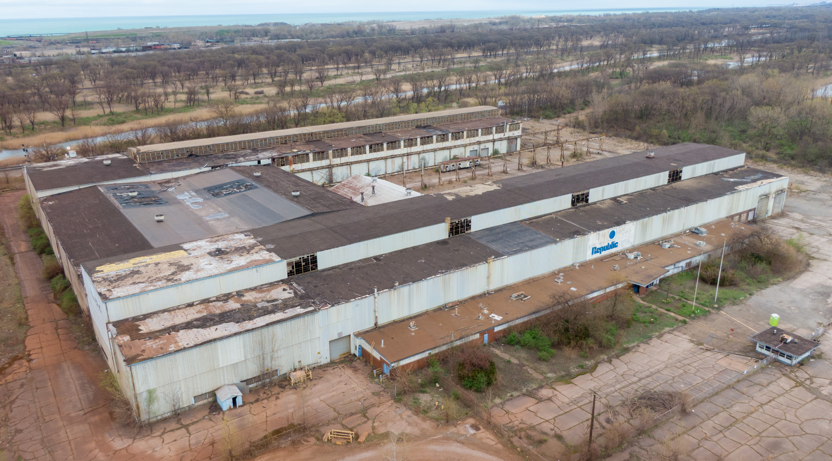
Aerial view of the 2800 E. Dunes Hwy facility in Gary.

Executive Overview Rent Rate: Undisclosed

Historical Legacy Meets Modern Utility:
• Originally constructed by Republic Steel, a pillar of U.S. industrial might.
• Ideal for companies looking to onshore production and avoid global tariffs.
• Ideal for fast tracking expansion of US manufacturing, warehouse, logistics or data center use.
• Substantial opportunity for redevelopment or tenant-specific customization.
• Pro-business environment with potential incentives from the City of Gary and State of Indiana.
• Expedite “Made in America” operations

Key Highlights:
• Total Floor Area: ~264,093 SF of flexible, open industrial space now available for lease.
• Zoning: M-3 Heavy Industrial Use permitted.
• Site Area: ~20 Acres.
• Structure: Steel-frame construction, high bays, large column spacing.
• Ceiling Height: ~30’+ with craneway throughout multiple sections.
• Crane Systems: Overhead cranes and heavy floor loads support large-scale operations.
• Power: Access to 15 MW via existing substation infrastructure.
• Rail Access: On-site spur with Class 1 rail infrastructure.
• Transportation: Direct access to NW Indiana logistics corridor via I-65, I-94, I-80 and Chicago Metro
• Global Shipping: Minutes from Port of Indiana (global waterway)
• Prime Onshoring Opportunity in strategic Midwest location

Strategic Location:
• Multimodal Transport Access: Adjacent rail spur with Class 1 rail access and close proximity to Port of
Indiana – Burns Harbor (approx. 8 miles), providing global shipping links via Lake Michigan. Easy
highway access to I-90/94 and I-65 enables efficient trucking to Chicago and nationwide.
• Strategic Location: Positioned in Gary’s industrial corridor on the Lake Michigan shoreline (the historic
heart of U.S. steel country), the site benefits from a strong labor pool and supplier network in Northwest
Indiana. It lies within the Chicago metro area for convenient access to markets and talent.
• Incentives: The State of Indiana and City of Gary is pro-development, with potential tax abatement and
economic incentives for large job-creating projects.

Transformation & Activation Opportunity:
The property’s scale and infrastructure present a unique chance to onshore manufacturing operations and avoid
global supply chain tariffs. Efficiently activate this historic industrial mill into a state-of-the-art production
facility capitalizing on existing rail and power infrastructure. The expansive building can be efficiently
reconfigured for single or multi-tenant use, making it suitable for a leased industrial and manufacturing campus,
warehouse, distribution hub, data center or other use. Ready for activation or redevelopment.

Detailed Description & Highlights
Expansive interior of the former Republic Steel mill, showcasing steel-frame construction and high clear heights. 2800 E. Dunes Highway is a substantial industrial facility encompassing ≈264,093 square feet under roof on approximately 20 acres of land. Formerly a manufacturing hub for Republic Steel, the property offers a robust industrial infrastructure that can be leveraged for modern manufacturing, processing, or logistics uses. Key highlights include 15 megawatts of available power (suitable for energy-intensive operations), active rail spur connectivity to mainline rail (critical for bulk material shipping), and M-3 Heavy Industrial zoning which permits a wide array of heavy manufacturing and distribution activities.
This single-story steel mill building features expansive open floor areas with high ceilings, overhead crane ways, and heavy floor load capacity – ideal for machinery, fabrication lines, or high-stacking warehouse storage. The structure is built for industrial durability, with a steel superstructure, reinforced concrete slab, and ample column spacing. Adjoining the main structure are auxiliary spaces for offices, employee facilities, and equipment rooms that can be renovated or expanded as needed. In total, the facility provides a rare combination of immense size, power, and logistics access, appealing to both industrial tenant-users and investors looking to reposition the asset for subleasing.
Key property highlights include:
- Massive Building Footprint: ~264,093 square feet of single-story industrial space with high clear spans, suitable for heavy equipment or high-volume warehousing.
- Robust Power & Utilities: Equipped with 15 MW electrical capacity (utility-grade power) and industrial utilities to support manufacturing, distribution, warehouse, or data center uses.
- Multimodal Transport Access: Adjacent rail spur with Class 1 rail access and close proximity to Port of Indiana – Burns Harbor (approx. 8 miles), providing global shipping links via Lake Michigan. Easy highway access to I-90/94 and I-65 enables efficient trucking to Chicago and nationwide.
- Strategic Location: Positioned in Gary’s industrial corridor on the Lake Michigan shoreline (the historic heart of U.S. steel country), the site benefits from a strong labor pool and supplier network in Northwest Indiana. It lies within the Chicago metro area for convenient access to markets and talent.
- Zoning & Incentives: M-3 zoning (heavy manufacturing) allows a wide range of industrial uses. The City of Gary is pro-development, with potential tax abatement and economic incentives for large job-creating projects.

Location & Accessibility

The site sits in the industrial corridor of Gary, Indiana, a city historically dominated by steel and manufacturing activity​en.wikipedia.org. This strategic location offers multi-modal transportation advantages for both inbound supplies and outbound product distribution:
- Highway Access: Immediate connectivity to the Borman Expressway (I-80/I-94) and the Indiana Toll Road (I-90), which together form a major east–west freight artery through the Midwest. The I-65 interchange (north–south route to the Indianapolis region and the South) is only a few miles from the property. This highway network enables easy truck transport to Chicago (approximately a 30-minute drive to downtown), Detroit, Indianapolis, and beyond.
- Rail Access: The property is rail-served, featuring an on-site spur capable of handling railcars. It connects to the regional rail network with Class I railroad service (via CN/Grand Trunk or Norfolk Southern lines in Gary) for heavy bulk shipping. This is a significant asset for industries that rely on rail for raw materials (such as steel coil, chemicals, or grain) or wish to ship finished goods cost-effectively cross-country.
- Port & Global Connectivity: The Port of Indiana – Burns Harbor on Lake Michigan is roughly 8 miles east, offering a direct water shipping route to the Great Lakes and St. Lawrence Seaway. Through the port, heavy cargo can reach international markets or arrive from overseas, making this site suitable for import/export-oriented operations. Additionally, Gary/Chicago International Airport is nearby, and Chicago’s O’Hare and Midway airports are within an hour’s drive, supporting corporate travel and air freight needs.
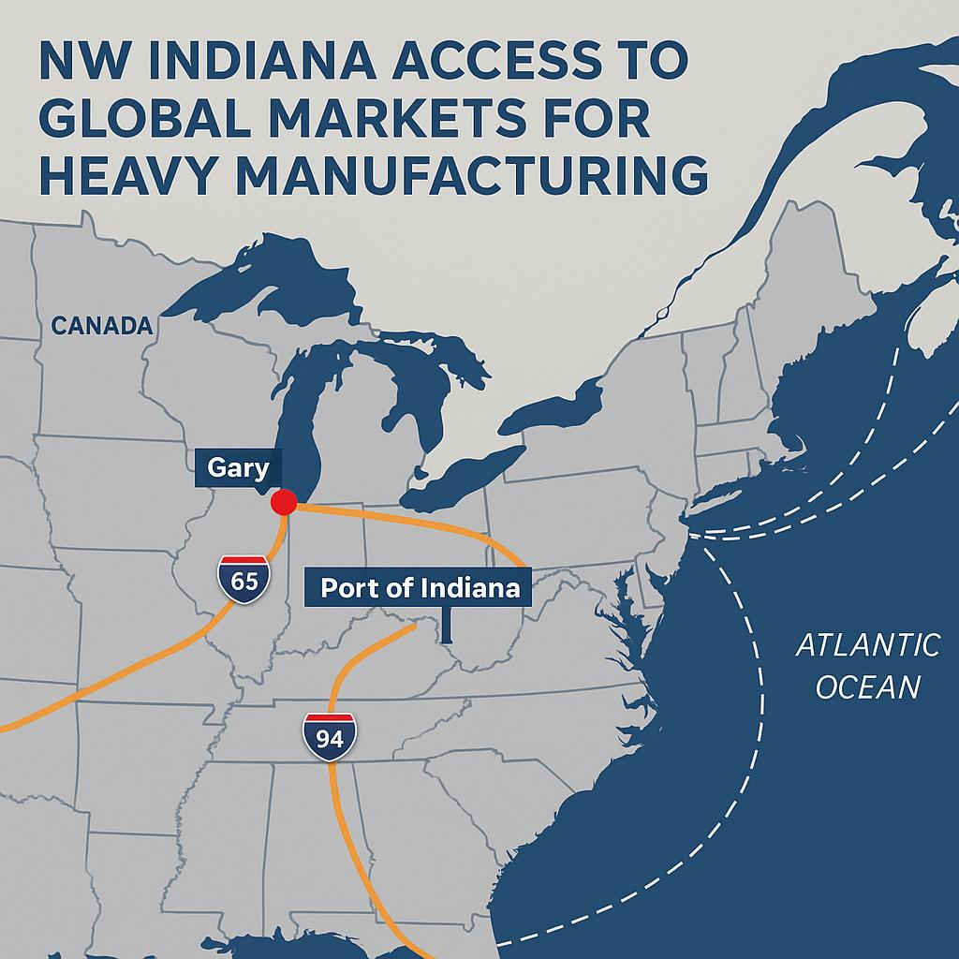
Situated at the nexus of these transport modes, the facility can readily integrate into national and global supply chains. Companies operating here can distribute products nationwide with 1-day truck transit to most Midwest markets, and also tap into Chicago’s extensive rail intermodal yards for coast-to-coast container shipments.

Historical Significance & Redevelopment Potential
This site has a rich industrial pedigree as part of Republic Steel’s Gary works, once contributing to the region’s steel production might. The massive building and surrounding grounds were purpose-built for heavy manufacturing, featuring robust utilities (industrial-grade gas, water, sewer) and even legacy environmental infrastructure (like on-site rail yards, crane systems, and reinforced foundations for furnaces or mills). As a brownfield redevelopment opportunity, the property offers “good bones” – a framework that can be revitalized rather than built from scratch. Investors and developers can save considerably on infrastructure costs by reutilizing the existing structural shell and utility connections. The wide-open interior bays (stretching hundreds of feet) allow flexible reconfiguration: whether for modern assembly lines, a regional fulfillment center, or subdivided into smaller manufacturing pods.
Gary’s economic development authorities are highly supportive of rehabilitating such legacy industrial sites. Similar projects in the area (for example, the redevelopment of another former Republic Steel plant by Alliance Steel) have enjoyed local government cooperation and incentives, reflecting a push to bring jobs back to this historically industrial city. The subject property’s location and scale position it for various adaptive reuses, including: heavy manufacturing (steel, foundry, machinery), battery or EV component production, large-scale recycling or metal processing, distribution warehouse serving Chicagoland, or even a multi-tenant industrial business park.
Redeveloping and activation of this site aligns with broader trends of onshoring manufacturing in the U.S. as companies are seeking domestic facilities to mitigate tariff costs and global supply chain risks. This property directly addresses that need with its ready-made industrial capacity. This facility is available to one large anchor tenant or an investor seeking multiple tenants, potentially achieving a high return on investment by leasing segments of the building for premium industrial rents once upgraded. Additionally, the acreage provides room for expansion or new construction (outparcel development, additional loading docks, or yard storage) if needed.

Site Specifications
Building Area: Approximately 264,093 square feet (single-story). The building is currently in shell condition, allowing a user to outfit it to specific requirements. Significant portions of the roof and walls are in place, and the interior is primarily clear span space with minimal supporting offices (which can be built-out or removed as needed).
Site Area: ~20 acres (≈ 871,200 SF) of land. The expansive yard can accommodate laydown areas, outdoor storage, or additional structures. There is ample room for truck courts, trailer parking, and railcar staging. The site’s footprint also offers potential for rail loop expansion or adding a spur for unit train access if required by heavy rail users.
Power & Utilities: 15 MW (15,000 kW) electric power capacity on site, fed by a dedicated substation capable of heavy industrial load. This high electrical capacity is a standout feature (far exceeding typical warehouse power) and can support energy-intensive processes such as arc furnaces, large-scale fabrication, or crypto mining data centers. Water, gas, and sewer services are available at industrial volumes/pressures, given the property’s past use in steel production. The facility could also be a candidate for renewable energy integration (e.g., rooftop solar or private substation upgrades) to further enhance power reliability and reduce long-term energy costs.
Loading & Rail: Multiple grade-level doors and high-bay openings exist for truck loading/unloading, and additional dock-high loading bays can be installed during redevelopment (the structure allows for knock-out panel installation). The property’s rail spur enters the site along the eastern boundary, with space to spot multiple railcars on-site. Class A rail service (with connections to national rail lines) means bulk materials can be delivered directly to the building, a rare feature for many industrial properties. This can dramatically lower the transportation cost for raw materials (steel, aggregates, etc.) or bulk product shipments.
Ceiling Height: Predominantly high bay industrial space; exact clear heights vary but much of the building offers 30’+ clearance at the center (with crane rails mounted at approximately 25’ height). This is sufficient for overhead crane operation and installation of mezzanines or tall racking systems if used for warehousing. The structural steel frame can support heavy roof-mounted equipment or additional craneways as needed.
Construction: Industrial-grade construction – steel framing with metal panel and masonry exterior walls. The foundations are reinforced concrete, engineered to bear extremely heavy loads (previously supporting steel mill machinery). Sections of the building have clerestory windows and vents from the mill days, providing opportunity for adding modern translucent panels or HVAC systems for a climate-controlled environment. Overall, the structure is sound, ready for retrofit, and far faster to adapt than a ground-up equivalent (with demolition of obsolete portions as an option to create more open yard or new construction area).

Investment & Tenant Appeal
From an investment perspective, this offering provides significant upside. The combination of scale, infrastructure, and location would be very costly to replicate today. By activating or repositioning this asset, an investor user could unlock substantial value through leasing the property for long-term operational use as the demand for well-located industrial space in the Chicago area continues to grow. The property’s proximity to Chicago (the nation’s third-largest metro) and placement in the logistics-rich Northwest Indiana region is ideal for potential tenant uses including manufacturing, warehousing, logistics operators or technology and data center. Additionally, the site’s heavy industrial M-3 zoning and existing rail/power features set it apart from generic industrial parks, meaning it can attract specialized users (such as steel or chemical firms, food processing with high power needs, etc.) that are less able to find suitable facilities.
For a tenant or end-user, this facility offers a turnkey solution for establishing a major operation with minimal off-site improvements needed. The heavy-duty utilities, rail access, and expansive building shell shorten the timeline to production/operation considerably compared to selecting raw land or lighter-duty buildings. A company can customize the space (install new roofing, modern lighting, material handling systems, etc.) on a solid base, and immediately leverage the location for distribution and workforce access. Northwest Indiana provides a skilled labor force in manufacturing and trades, thanks to the area’s industrial heritage. Moreover, locating in Gary can help a company reduce logistics costs (close to suppliers in the steel/plastics/chemicals clusters of the Midwest) and avoid import tariffs by producing domestically – a significant advantage for metals and manufacturing firms in the current global trade climate.
Transformation & Activation Opportunity:
The property’s scale and infrastructure present a unique chance to onshore manufacturing operations and avoid global supply chain tariffs. Efficiently activate this historic industrial mill into a state-of-the-art production facility capitalizing on existing rail and power infrastructure. The expansive building can be efficiently reconfigured for single or multi-tenant use, making it suitable for a leased industrial and manufacturing campus, warehouse, distribution hub, data center or other use. Ready for activation or redevelopment.

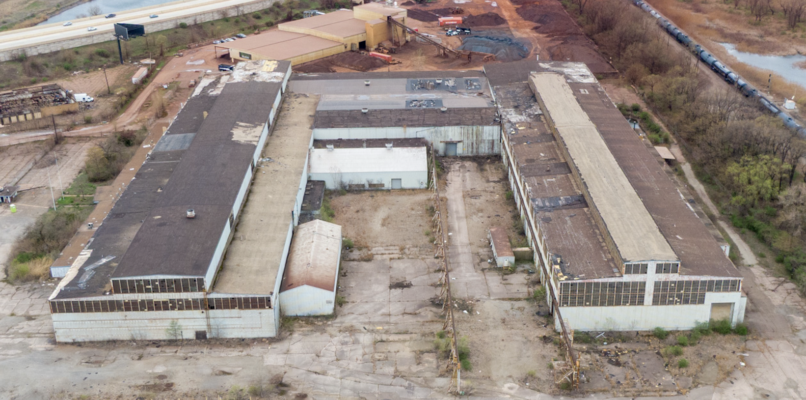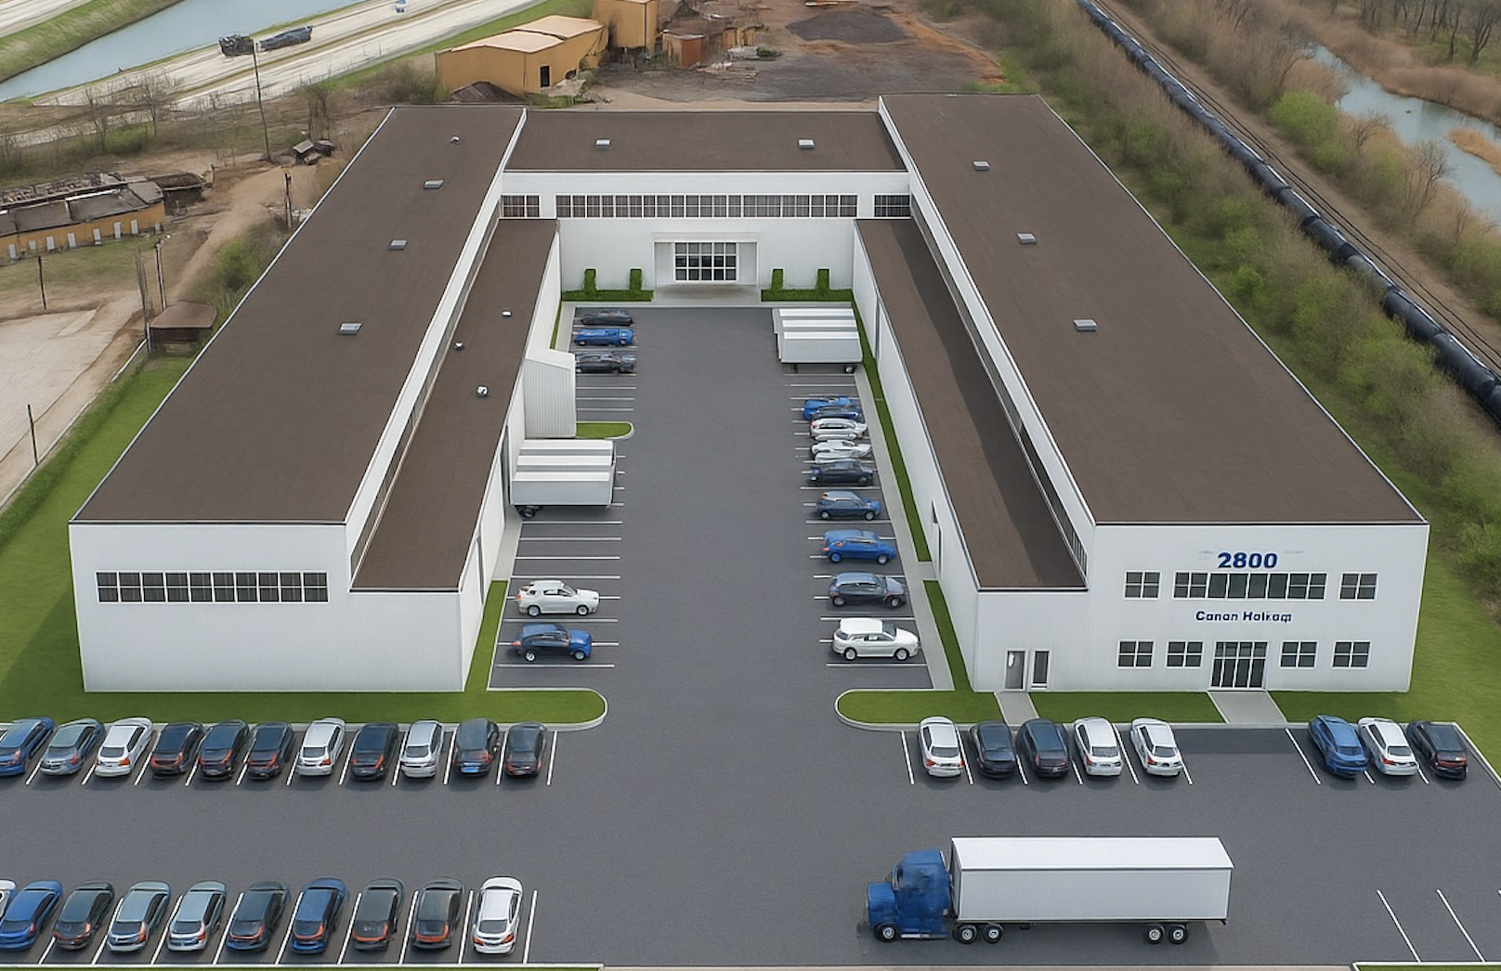
Today Transformation & Activation

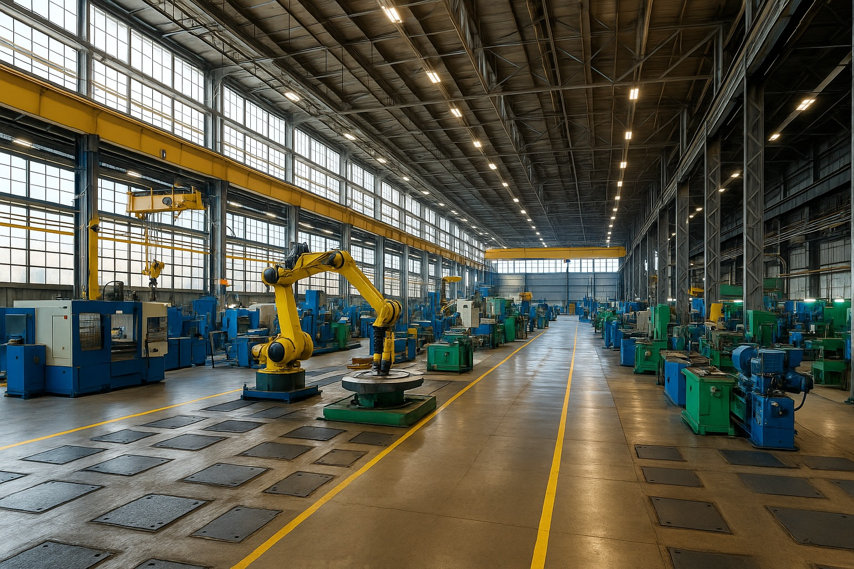

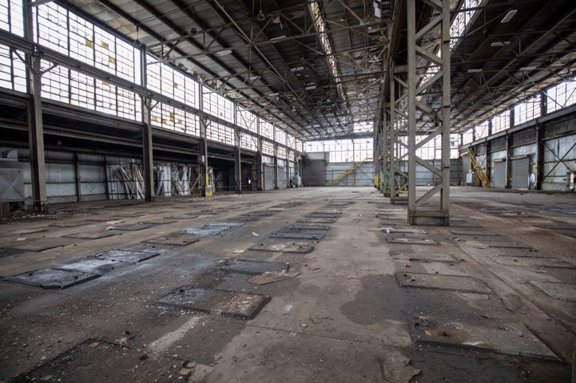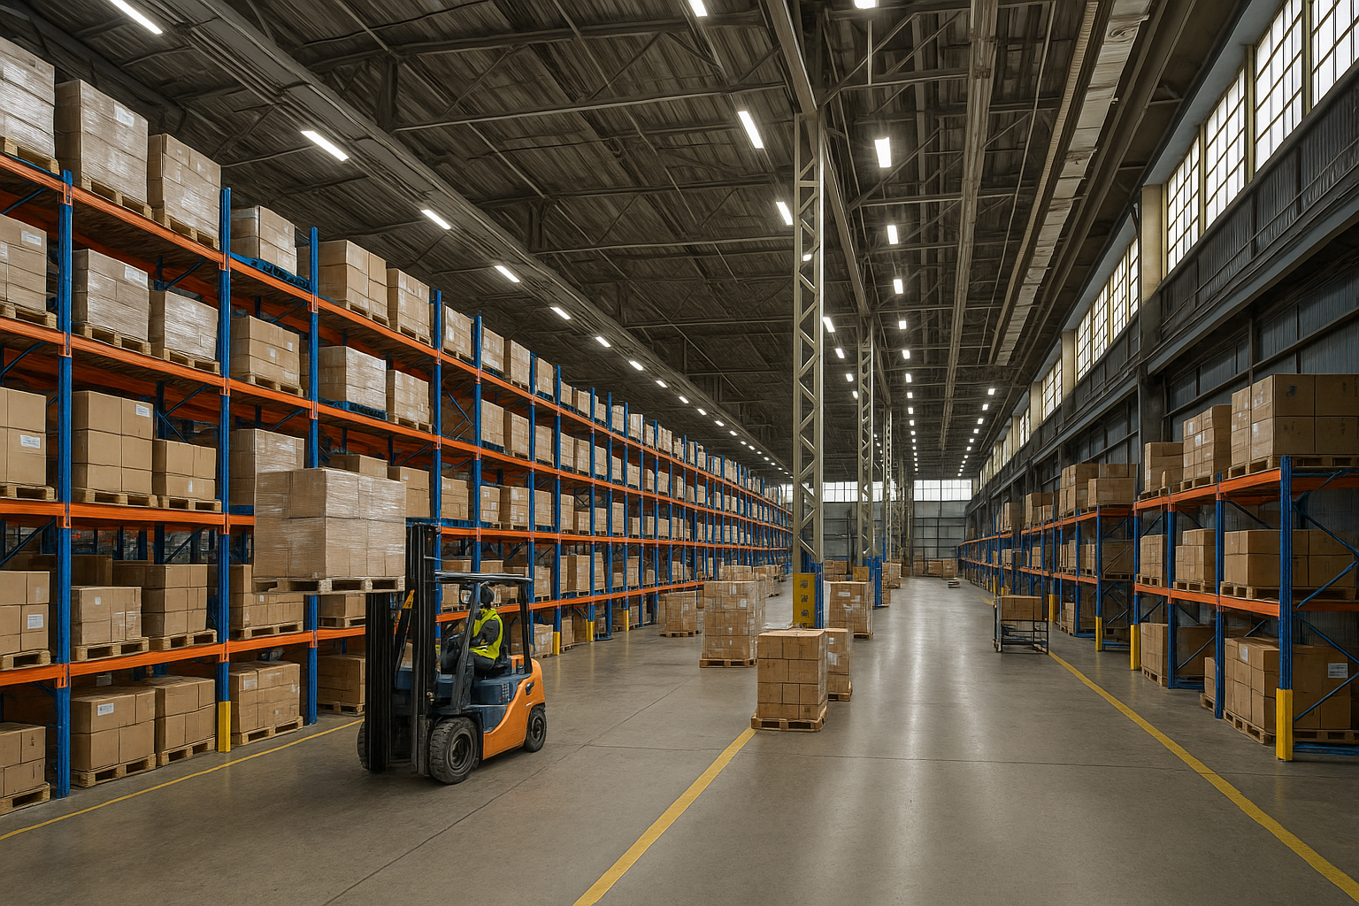

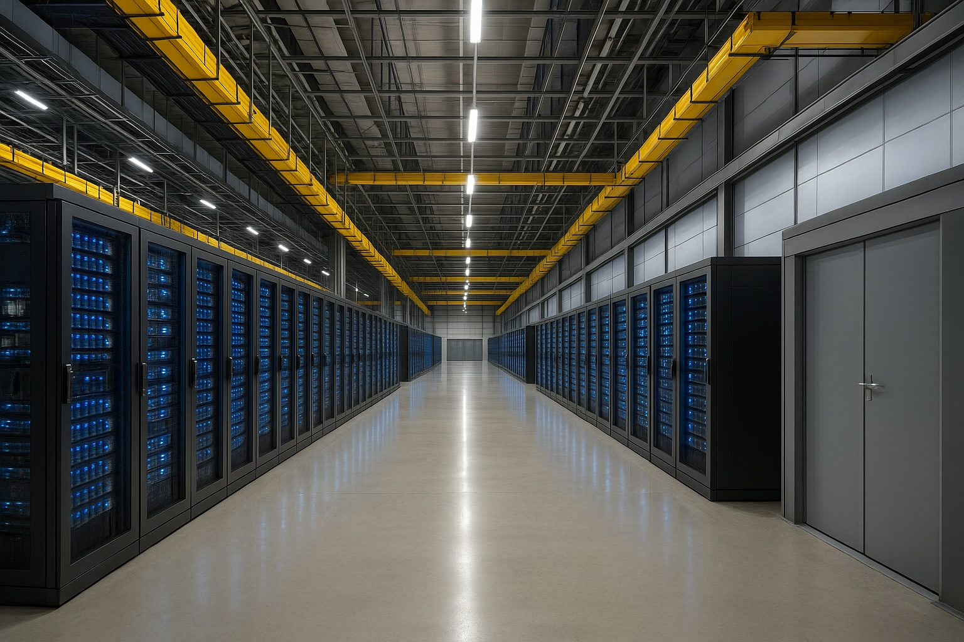

Property Video & Photo Highlights

- Video: Provides a bird’s-eye view of the facility and its vast surrounding yard, highlighting the building’s footprint along with photos of the expansive interior space and transformation rendering. The aerial view shows the nearby highway infrastructure and the industrial nature of the immediate area, underscoring the site’s logistical advantages.

- Photos: Shows the expansive interior space of the plant. The photo reveals the tall ceilings, extensive crane rails, and the “blank canvas” nature of the factory floor, allowing investors/tenants to imagine their production lines or storage systems in this wide-open space.

Video: Link to Download Property Video

Photos: Link to Download Property Photos

