
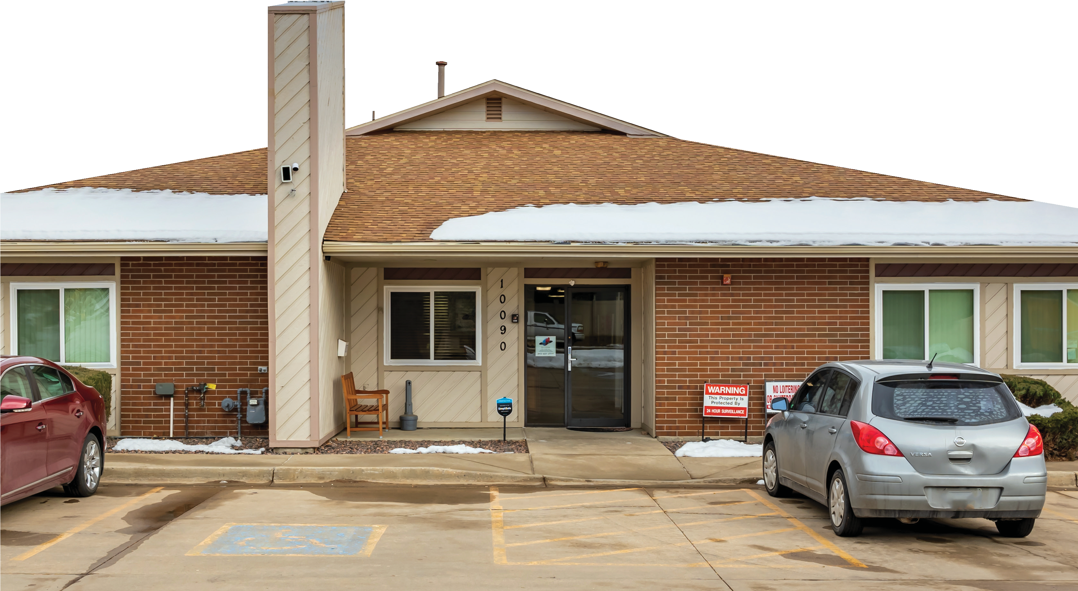

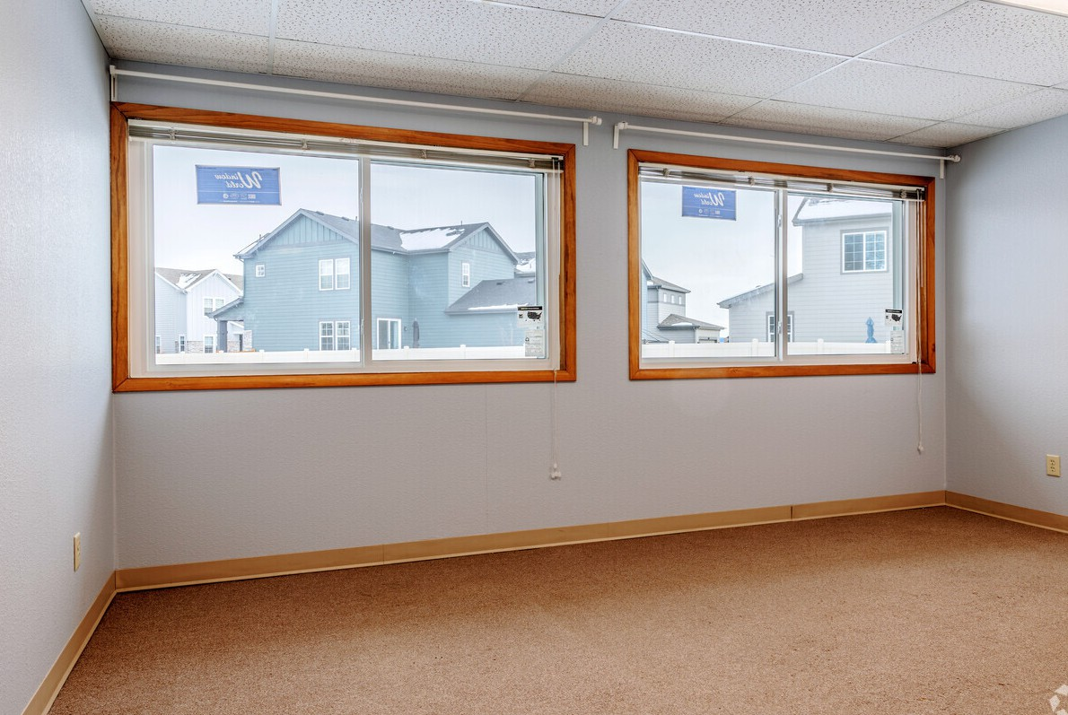
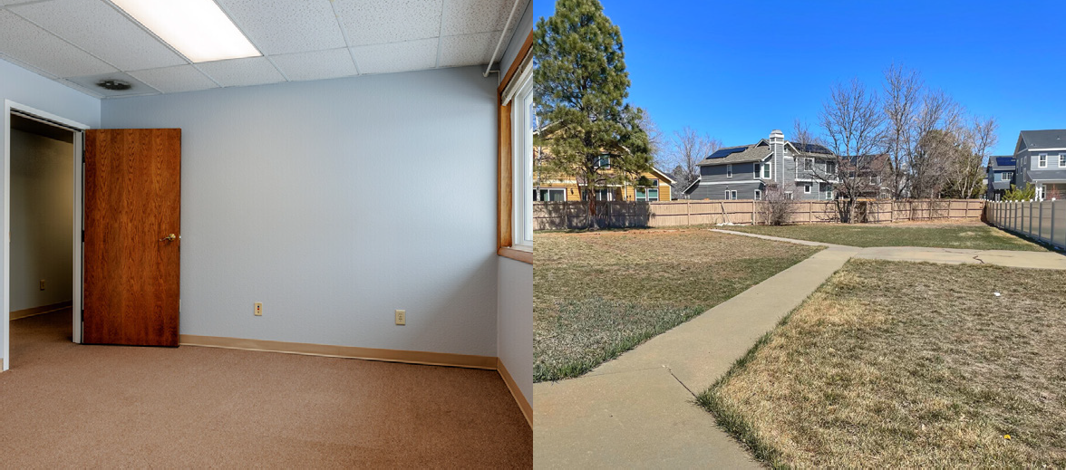
10090 Garrison St

Westminster, CO 80021, USA

OFFERING SUMMARY

Jen Aragon
Principal
720.937.0354
jenny@rockymountain-re.com
Building Size 5,452 SF

Available 163-346 SF

2 Units (106, 107)
Year of Construction 1989
Renovated 2006
Parking 26 striped spaces
Site Size 0.79 AC
County Jefferson
Lease Rate $28.00/SF FS

The information contained herein has been obtained from sources Rocky Mountain Real Estate deem reliable. No representation or warranty is made of the foregoing information. Terms of the sale and availability is subject to change without notice. The marketing information has been prepared by Rocky Mountain Real Estate to

is responsible to conduct a thorough due diligence investigation.

PROPERTY HIGHLIGHTS FLOOR PLAN

- Private entrance
Storage
New Office
Utility Room
104
New Office
Bathroom
105
Conference Room
Front Dest
File Room
Kitchen/ Lunchroom
ADA
Bathroom
Storage
Bathroom
106
112A
111A
110A
108
107
112B
111B
110B
109
 |  |  | 101 |  |  | 102 |  |  | 109

- Great space for Professional, Healthcare, Financial and Technology Companies
- ADA Restroom
- New paint
- Back patio and large fenced outdoors space
- Free Wi-Fi
- Building signage available
- Abundant parking
- Secure access
- Great natural light

SITE PLAN

TommStandley Lake High Schooly knocker
W 104TH AVE

121

Walnut Creek Apartments

Walnut Creek Apartments

10090
Garrison St
W 100TH WAY
WADSWOTTH PKWY

10090 Garrison St
Westminster, CO 80021, USA

W 101ST AVE
GARLAND ST

a division of HTLF Bank


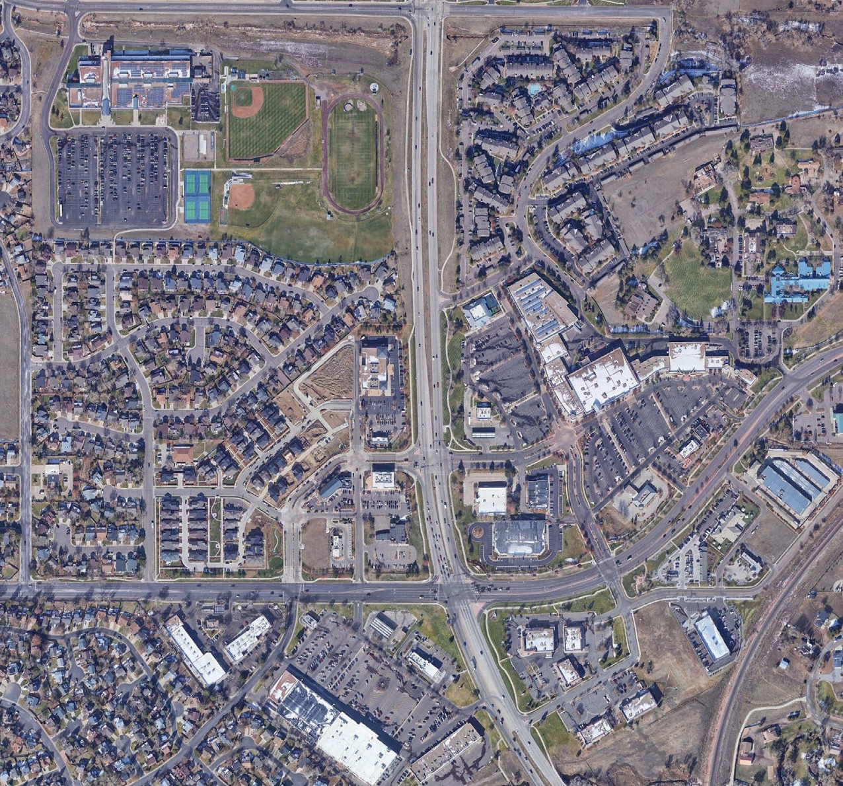








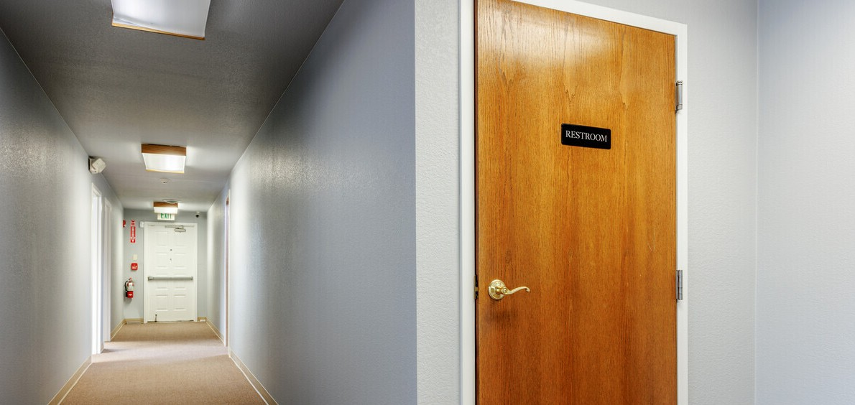
Comfort Dental
Oral Surgery

La-Z-Boy Furniture Galleries

W 100TH AVE
Westminster
Storage Etc...
GARRISON ST
Primrose School at Standley Lake
Westbrook Shopping Center
Church Ranch Car Wash
W 101ST PL

121
Standley Shores Shopping Center
Caliber Collision

LaMar's Donuts and Coffee

Jen Aragon
Principal 720.937.0354
jenny@rockymountain-re.com

