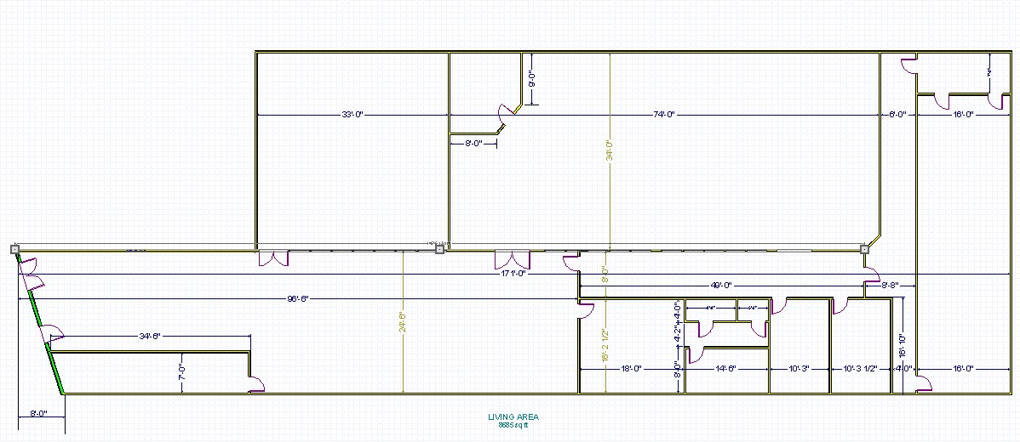
SUITE D
STORAGE
MEN’S ROOM
WOMEN’S ROOM
SUITE C
SUITE B
SUITE A
SUITE | TENANT | BUSINESS | SF | COST/SF | NNN/SF/YEAR | UTILITIES: $/SF/YEAR | TOTAL COST/SF/YEAR | TOTAL  MONTHLY
A |  |  | 1,122 | $12.00 | $2.40 | $1.58 | $15.98 | $1,500.00
B |  |  | 2,516 | $12.00 | $2.40 | $1.58 | $15.98 | $3,350.00
C |  |  | 1,776 | $12.00 | $2.40 | $1.58 | $15.98 | $2,365
D |  |  | 300 | $12.00 | $2.40 | $1.58 | $15.98 | $400
5132 Park Heights
Existing Floor Plan w/ Lease Rates

