Sublet a calm, beautiful, fully furnished treatment office (or change furniture to suit your needs) in quiet area of NW medical Las Vegas. 2 min from 95N freeway. Single person business, acupuncturist, or other practitioners are welcome. 1 room with a waiting room area $800/month, all utilities, internet, security, annual maintenance and cleaning fees included. Practice supplies, software, liability insurance, additional furnishings are not included (eg: treatment linens and supplies, practice software, practice liability, etc). Subtenant must purchase general liability and professional insurance.
Receptionist support is available for an additional fee.
Office is scent- and smoke-free; renter agrees not to wear perfume/cologne.
Pictures attached.
Contact Lisa Grant OMD for more details: 702-539-9185
Address: 7381 Prairie Falcon Rd. Ste 140, Las Vegas, NV 89128
Entrance:
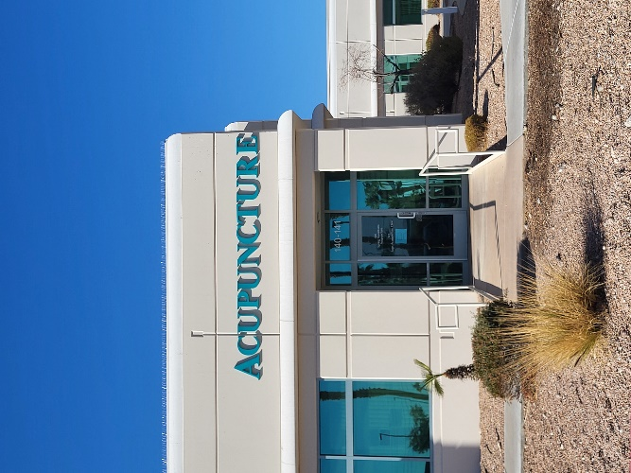

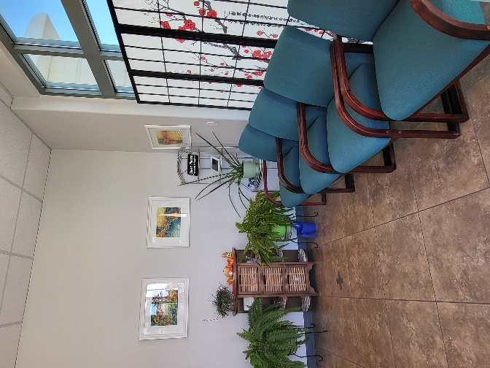
Waiting Area:

Treatment Room. Any and all furniture can be removed; subtenant may furnish it as they wish.
