Maynard & Bartlett Realty Group, LLP
For Sale 18,000 SQ FT Office Building

4546 Highway 78, Loganville, GA 30052
Sales Price: $1,595,000

Lee Bower, Agent
Maynard & Bartlett Realty Group, LLP
31 South Center St.
Winder, GA 30680

Contents

Introduction 1
Property Description 2
The Facts 6
Construction Details 9
Walton County Area Analysis 11
Demographics 13
Subject Neighborhood Analysis 15
Appendices 16

Introduction

Presented By: | 
Lee Bower, Agent

Direct: 770-867-4758
Cell: 770-356-4578
Email: leebower@maynardrealty.com

Maynard & Bartlett Realty Group, LLP
31 South Center St.
Winder, GA 30680

Property Description

Property Description
 | 4546 Highway 78, Loganville, GA 3052
 | The building is an 18,000 SQ FT two-story Colonial style designed office with each story containing 9,000 SQ FT. This is a beautiful building with excellent road frontage on Highway 78. This site not only has great road frontage but it also enjoys great visiblity to Hwy 78 as well. Highway 78 is a direct route between Atlanta and Athens. This property also has a large nice electronical scrolling sign in front of building to help draw customers or clients. This building had a new architectural shingled roof installed in 2006. THIS PROPERTY IS PRICED TO SELL!! GREAT BUY FOR AN INVESTOR OR AN OWNER/OCCUPIER.
Related Facts | No. | Description | Pg.
 | 1 | Location | 3
 | 2 | Site Size, Shape and Frontage | 3
 | 3 | General Access | 4
 | 4 | Topography and Drainage | 4
 | 5 | Soils and Subsurface | 5

Location | 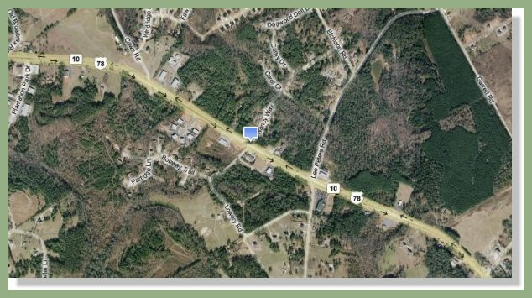
 | The subject property is identified as 4546 Highway 78, Loganville, Georgia by the U.S. postal Service. The subject property is located on the north side of Highway 78, west of its intersection with State Route 81 and east of its intersection with State Route 20 in the City Limits of Loganville in Walton County, Georgia.

Site Size, Shape and Frontage | 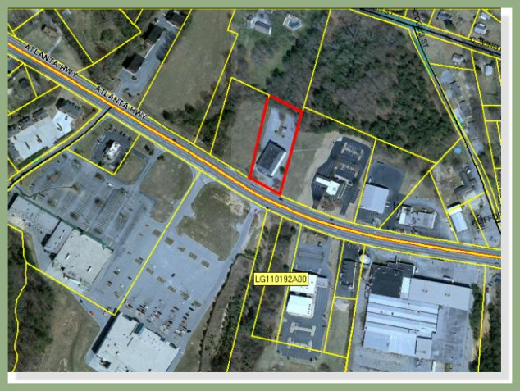
 | The subject property is described by legal description and the Walton County tax plat as a rectangular shaped tract of land containing 1.17 acres with frontage along the northern boundary of Highway 78.

General Access | 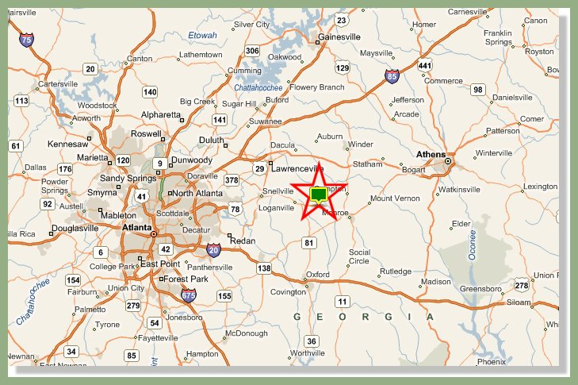
 | General access to the subject property is good. The subject has good access to the Central Business District of Loganville via Highway 78. It has good access to the City of Monroe to the east, and the City of Snellville to the west. It has average access to the Central Business District of Atlanta to the west. The subject has one point of access; a single driveway along Highway 78. Highway 78 is an asphalt paved four lane unrestricted road with a central turn lane.

Topography and Drainage | The topography slopes up from road grade to become generally level for the most part. Drainage on the property appears adequate. The subject is not located within a designated flood plain area. It is designated as flood zone X. Reference to FEMA Flood Rate Map Panel Number 130326 0005A dated July 16, 1982.

Soils and Subsurface | 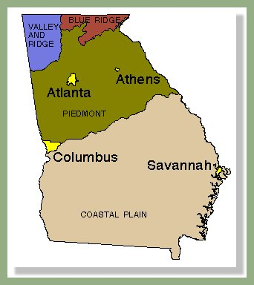
The subject is located in the Southern Piedmont Region of Georgia. The Southern Piedmont stretches from the Sand Hills to the foot of the Appalachian Mountains and covers nearly 10.5 million acres. Elevation ranges from 500 10 1500 feet above sea level. Topography is gently rolling to steep. The soils are underlain by acid crystalline and metamorphic rocks. Dominant soils of the Southern Piedmont have mostly clay sub-soils and Kaolinitic minerals.

A report by a soil and subsurface engineer regarding the subject site has not been made available to the appraiser. A visual inspection of the property did not reveal any obvious problems. However, the appraiser is not qualified to detect such problems. The client is advised to obtain a soil and subsurface expert if desired.

The Facts

The Facts
 | 4546 Highway 78, Loganville, GA 3052
Related Facts | No. | Description | Pg.
 | 1 | Facilities | 7
 | 2 | Property and Amenities | 7
 | 3 | Location | 8
 | 4 | Lot Size | 8
 | 5 | Zoning | 8
 | 6 | Parking | 8
 | 7 | Sales Price | 8
 | 8 | Per Square Foot | 8

Facilities:
Improvement consists of a two-story, colonial design office building with each story containing 9,000 square feet. There is approximately 16,000 square feet of net rentable space in the building.

Property and Amenities: | 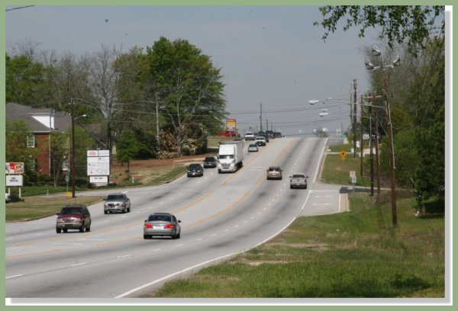
The property is advantageously located along the Northern side at U.S. Highway 78 east of its intersection with State Route 20 and west of its intersection with State Route 81 in the city limits of downtown Loganville.

There is a substantial amount of office furniture that goes with the building, including a fully equipped kitchen and conference room table and chairs.

Location: | 4546 Highway 78, Loganville, GA 30052  Walton, County Georgia

Lot Size: | 1.17 Acres

Zoning: | C H- Commercial Highway

Parking: | 66 Spaces

Sales Price: | $1,595,000

Per Square Foot: | $ 88.00

Construction Details

Construction Details
Related Facts | No. | Description | Pg.
 | 1 | Built | 10
 | 2 | Foundation | 10
 | 3 | Exterior Walls | 10
 | 4 | Roof | 10
 | 5 | Floors | 10
 | 6 | Windows | 10
 | 7 | Ceilings | 10
 | 8 | Lighting | 11
 | 9 | Plumbing | 11
 | 10 | Mechanical | 11
 | 11 | Sprinklers | 11

Built: | 1989

Foundation: | Reinforced Concrete Slab

Exterior Walls: | Dryvit-Stucco over Wood Frame.

Roof: | Architectural Shingled Roof, Installed 2006.

Floors: | Finished Area – Carpet or Tile over Web Floor Trusses.  Restrooms – Tile over Concrete.

Windows: | Double Hung.

Ceilings: | 2x4 Accoustical Lay-in Tile.

Lighting: | Lay-in Florescent Lighting.

Plumbing: | Seven - 2 Fixture Bathrooms.

Mechanical: | Central HVAC – Eight Units

Walton County Area Analysis

Walton County Area Analysis
 | 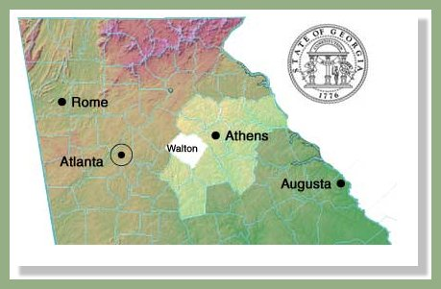
 | Walton County is located in the northeast quadrant of the State of Georgia. Walton County is located north of Newton and Morgan Counties, west of Oconee County, south of Barrow County and east of Rockdale and Gwinnett Counties. Walton County contains 329 square miles. Cities in Walton County include Good Hope, Monroe (County Seat) Social Circle and Walnut Grove.
Related Facts | No. | Description | Pg.
 | 1 | Population | 12
 | 2 | Housing | 12
 | 3 | Employment | 13

Population | A population analysis reveals that Walton County's growth has increased at a rapid rate between 2000 and 2005. The 2000 population estimate was 60,687 persons as compared to 75,647 persons in 2005. This is a rate 24.7% increase between the period of April 1, 2000 to July 1, 2005. The population increase for the State of Georgia during the same period was 10.8% Between 1990 and 2000, Walton County’s population increased at a rate of 57.3% compared to the State’s rate of 26.4% According to the U.S. Census Bureau, in 2000 there were 184.4 persons per square mile. This is compared to 141.4 persons per square mile statewide.

Housing | There were 27,801 housing units in Walton County in 2004. In 2000, there were 22,500 housing units. Of these housing units, approximately 17,814 (79.1 %) were one unit attached or detached dwellings. The predominate values range from $100,000 to $300,000. The home ownership rate in 2000 was 76.5%. This is compared to the State’s 67.5% home ownership rate.

Employment | Walton County had a 2000 labor force of 30, 409 persons with an unemployment rate of 2.3%. This is compared to an unemployment rate of 3.4% for the State of Georgia and 3.8% for the United States.

Demographics

Demographics
Industry | Number of Employees | Percentage
Agriculture, forestry, fishing, and | 318 | 1.1
hunting, and mining.
Construction | 4,450 | 15.2
Manufacturing | 5,056 | 17.2
Wholesale Trade | 1,313 | 4.5
Transportation and Warehousing and | 1,591 | 5.4
Utilities
Information | 993 | 3.4
Finance, insurance, real estate, rental | 1,755 | 6.0
And leasing
Professional, scientific, management, Administrative, and waste management services | 2,052 | 7.0
Educational, health and social services | 4,007 | 13.7
Arts, entertainment, recreation, Accommodation and food services | 1,512 | 5.2
Other services (except public | 1,518 | 5.2
Administration)
Public Administration | 1,276 | 4.3
Retail Trade | 3,512 | 12.0
Table 1:

Demographics
Related Facts | No. | Description | Pg.
 | 1 | Income | 15
 | 2 | Transportation | 15
 | 3 | Overview | 15

Income | The county per capita personal income in 2000 was $19,470, as compared with $27,324 for the State of Georgia and $28,546 for the United States. The median household income in 2000 was $52,386.

Transportation | In the year 2000, approximately 22.953 persons commuted alone via personal vehicle. As such, Walton County’s roads system is an important part of transportation. The major transportation arteries in Walton County include US Highway 78, State Route 138, State Route 20, State Route 81, State Route 11 and State Route 186. Hartsfield-Jackson Atlanta International Airport is located approximately less than an hour’s drive from Walton County.

Overview | Walton County is experiencing an influx of new residents which has contributed to an ongoing transition of the county being predominately rural to an increasingly affluent community. The overall economic and social outlook for Walton County is favorable primarily due to the combination of an increasing population and industry diversity.

Subject Neighborhood Analysis

As previously stated, the subject property is located on the north side of Highway 78 within the City Limits of Loganville. Generally speaking, this is the neighborhood of the subject property as the most intensive use of commercial properties is along the Highway 78 corridor.

The population of Loganville has rapidly increased. The 2000 population estimates were at 5,435 persons. This is compared to the 2005 population estimates of 9,000 persons. This represents a 66% increase over a five-year period.

Historically, commercial properties were located along Main Street in the older Central Business District of Loganville. As growth in Metropolitan Atlanta increased, resulting in “urban sprawl”, the growth in the city of Loganville increased exponentially. Over the past nine years, there has been a measurable increase in commercial businesses in the city of Loganville. These businesses include uses such as strip retail centers, free standing retail, restaurants, banks, service stations, etc.

In the year 2005, there were 156 new businesses in the city of Loganville. The commercial business base over the past three years increased from 642 businesses to 952 businesses. This type of demand along Highway 78 is observed from the City of Snellville to the west to the City of Monroe to the east with new construction and demolition of older improvements and reconstruction.

With the new construction of residential, office, industrial, and commercial improvements in the subject neighborhood, there is no evidence that the market demand will decrease in the near future. Based on this information, it is the opinion of this appraiser that the subject is a marketable site.

Additional Photos



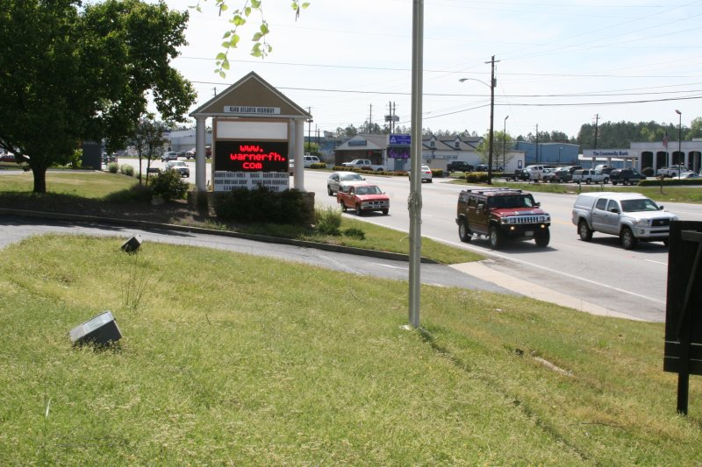

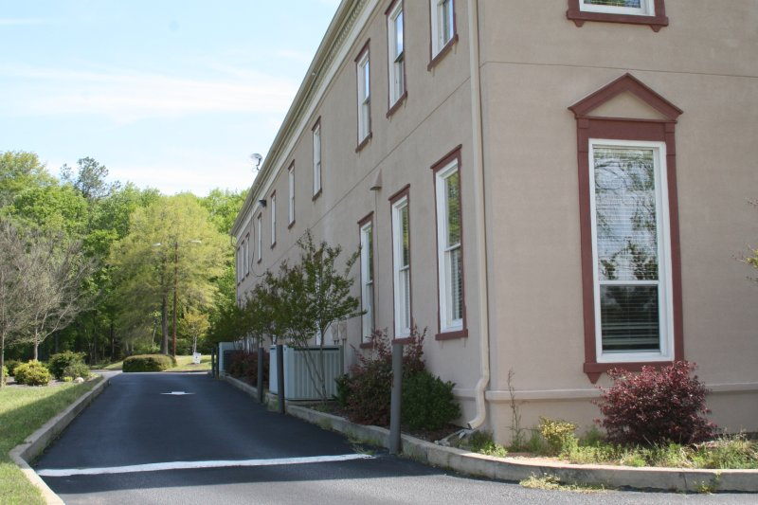

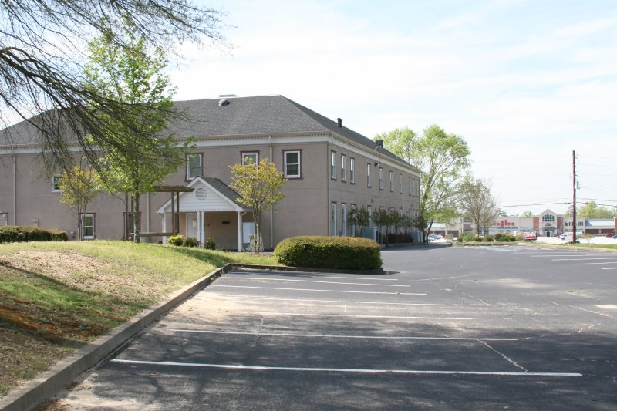

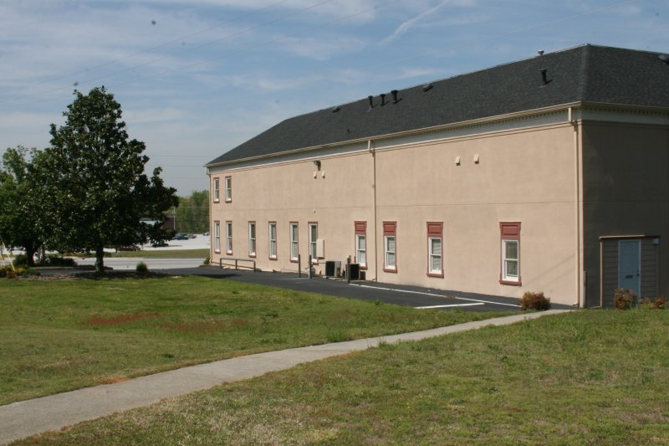

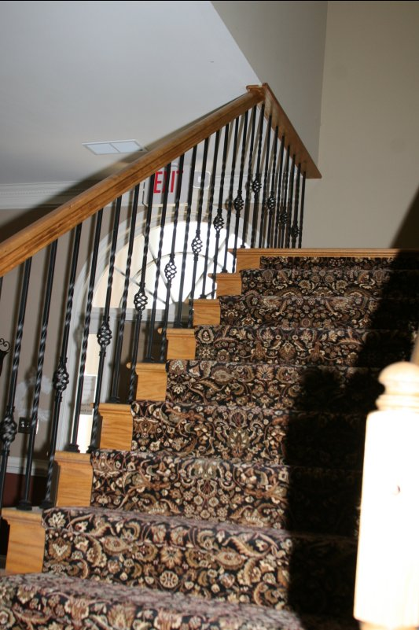

Appendices

Floor Plan 1: | 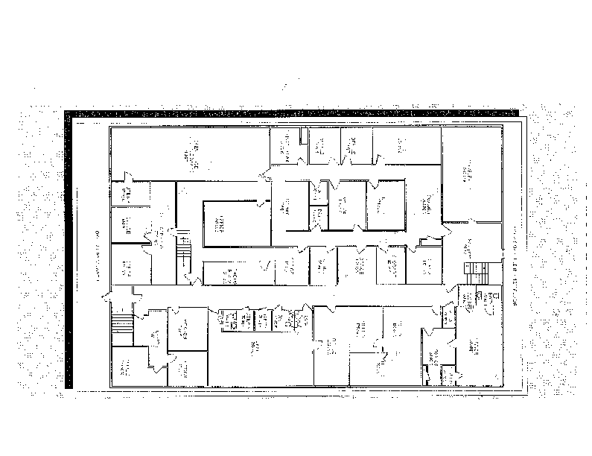  Figure 1: Current Floor Plan
 | See attachments.

Floor Plan 2: | 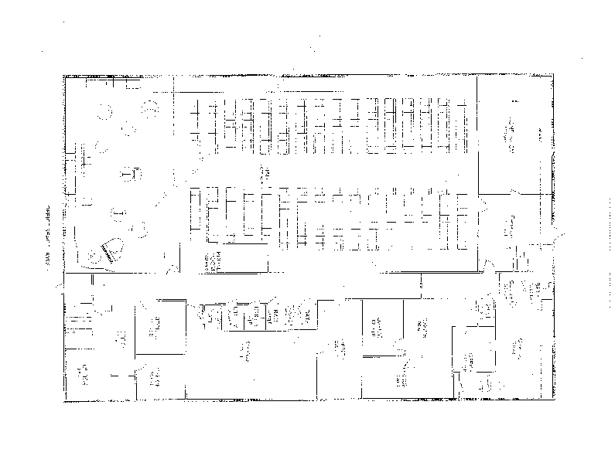  Figure 2: Floor Plan with Church
 | See attchments.

Floor Plan 3: | 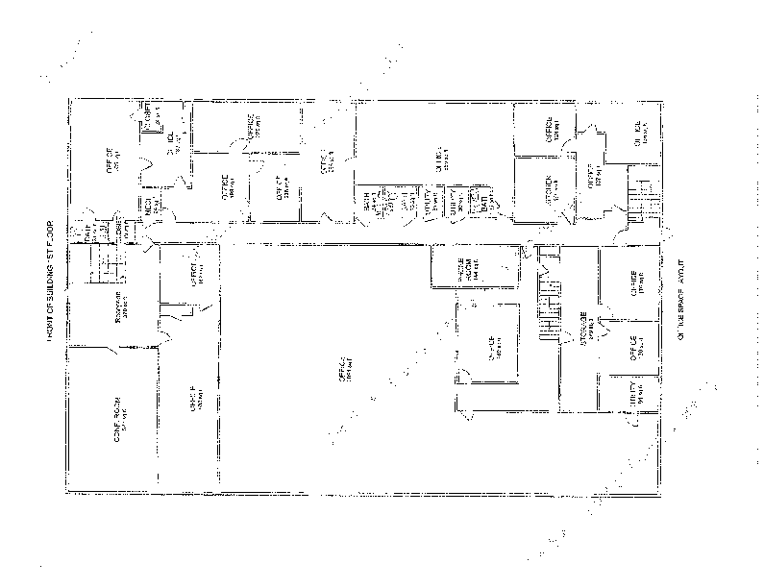  Figure 3: Floor Plan for Open Lower Level, No Church
 | See attachments.

