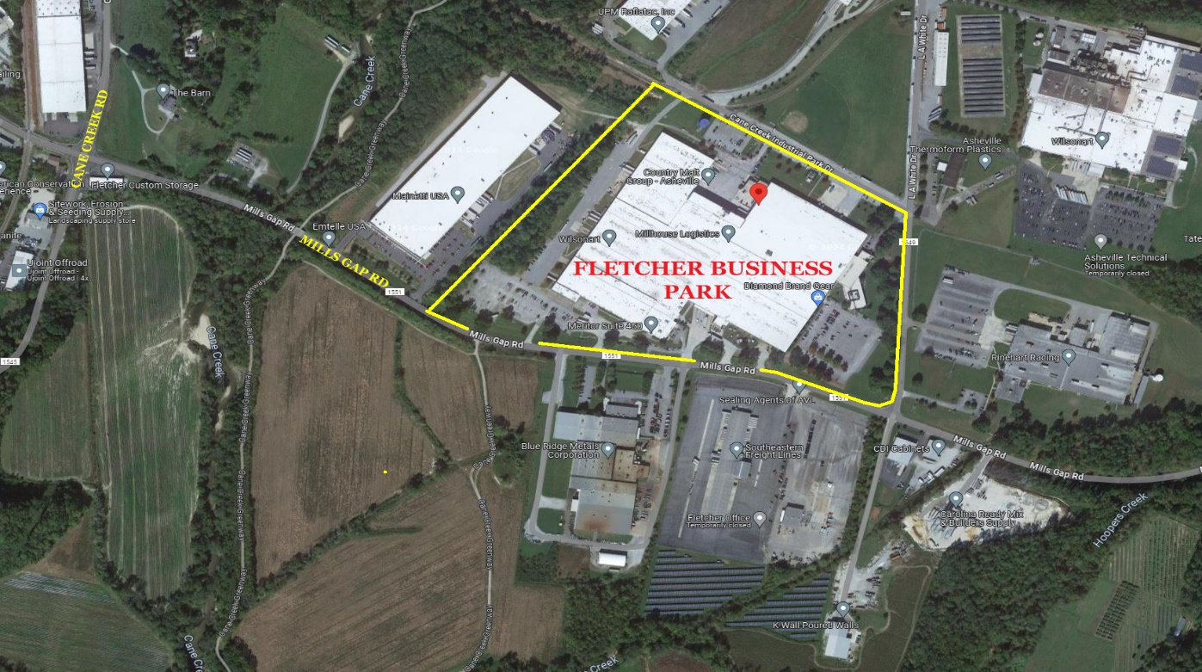
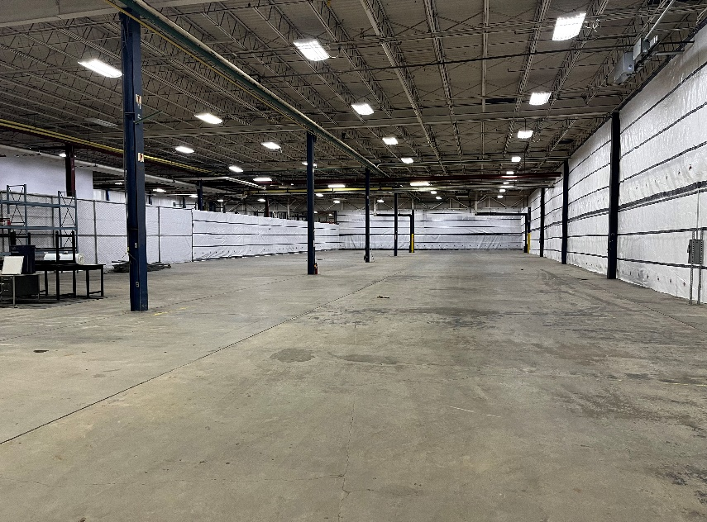
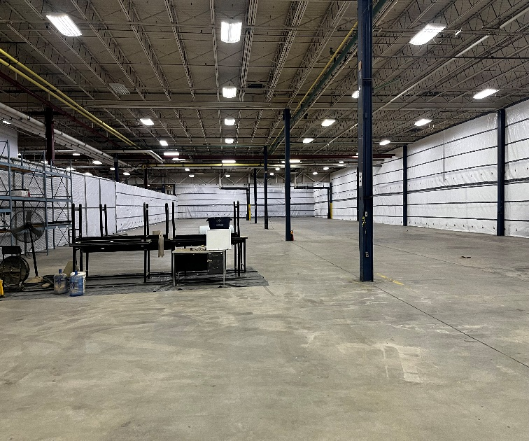

- 1,000 sf of Office space plus
- 21,065 sf of Warehouse
- 2 Truck Docks Available with 1 Roll Up Door
- 21 ft high ceilings
- 40 x 40 column spacing
145 Cane Creek Industrial Pk Ste. 375
22,065/sf Unit includes:
1,000/sf of Office
21,065/sf of Warehouse
NOW LEASING
$8.75/psf NNN

