

141 New Street Suite 10 & 11
Decatur, Ga 30030
2800 sq. ft.

Unit Details
Approx. 2800 sq ft. Office and warehouse space
Air Conditioned Warehouse space
2 bathrooms
Kitchen
End unit
Drive-in dock door
Conveniently located 1 mile from Downtown Decatur/Decatur Square
One block from Avondale Marta Train Station

$3966 rent/mo/NNN Cam, Tax, Insurance, & HVAC approx $1621 Electric and Gas responsibility of TT; LL bills water monthly

Total Monthly rental Amount $5587.00
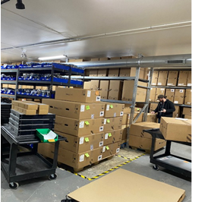

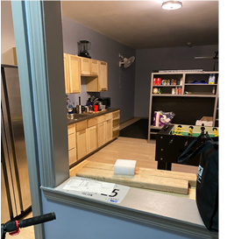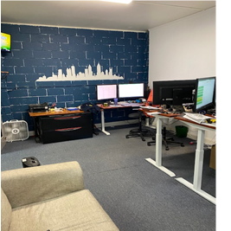

Leasing requirements:
- Personal guarantee required
- Personal credit score of 675 or more required
- First month’s rent and security deposit due at lease signing
- RENT + CAM + UTIL+ TI + HVAC replacement fee= monthly payment

Broker Commission:
*Brokers to be paid ½ of first month’s rent with 5% residual.
**Brokers must make first contact with EDS Leasing office for commission to paid on executed leases by EDS. If EDS shows the tenant the property first, tenant will be responsible for Broker’s Commission.

