COMMERCIAL RETAIL SPACE
LEASE PROPOSAL — SUITE #1
4170 E. Waterloo Road | Stockton, CA 95215 | State Route 88 / Piccoli Road Corner
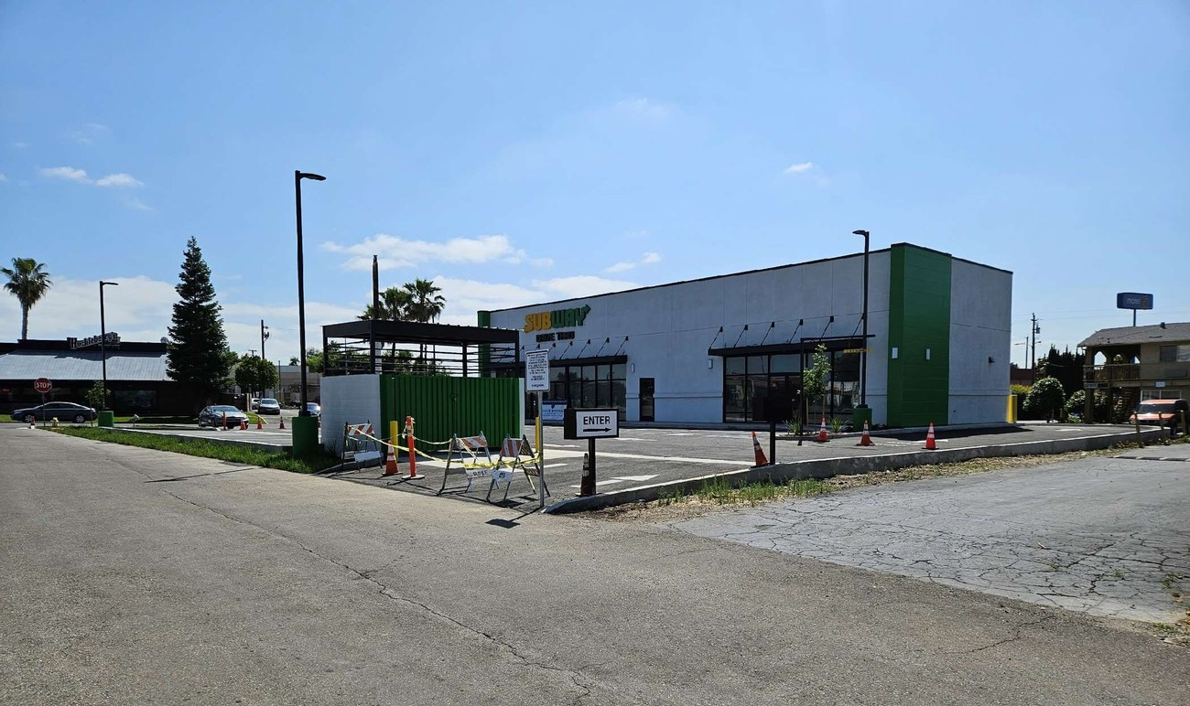
4170 E. Waterloo Rd — Subway Drive-Thru Anchor & Suite #1 Available
SPACE AT A GLANCE

Feature | Detail
Address | 4170 E. Waterloo Rd, Suite #1, Stockton CA 95215
Ground Floor SF | 1,142 SF
Upstairs Office | 300 SF
Total Usable Space | 1,442 SF
Condition | Gray Shell — Sheetrock installed, ADA restroom complete
Grease Trap | 1,200-gallon tank on premises
HVAC | Roof-mounted unit installed (ductwork not complete)
Signage | Pole signage available
Co-Tenants / Proximity | Subway Drive-Thru on-site; McDonald's, Taco Bell, Denny's nearby
APN | 101-180-13

NNN EXPENSE BREAKDOWN (TENANT'S PROPORTIONATE SHARE)

The space is approximately 40% of total building area. NNN charges are reconciled annually based on actual costs — no management fees or inflated line items.

NNN Expense Item | Annual Cost | Tenant Share (40%) | Monthly (÷12)
Property Taxes | $12,000 | $4,800 | $400
Insurance | $7,500 | $3,000 | $250
Flood Insurance | $5,500 | $2,200 | $183
Trash | $7,000 | $2,800 | $233
Water | $3,000 | $1,200 | $100
Landscaping | $4,200 | $1,680 | $140
TOTAL | $39,200 | $15,680/yr | ≈ $1,307/mo

Estimated Monthly NNN: ≈ $1,307/month (based on current actual expenses — reconciled annually)

RENT STRUCTURE — STANDARD LEASE

Rent commences upon landlord approval to open. Startup support is built into the first year to give tenants time to ramp operations. Annual increases thereafter are fixed at 3% for predictability.

Phase | Period | Monthly Base Rent | NNN | Total / Month
Startup Support | Months 1–6 | $2,500 flat | Included | $2,500
Transition | Months 7–12 | $3,000 flat | Included | $3,000
Standard — Year 2 | $2.00/SF × 1,142 SF | $2,284 | $1,307 | $3,591
Standard — Year 3 | $2.06/SF × 1,142 SF | $2,353 | $1,307 | $3,660
Standard — Year 4 | $2.12/SF × 1,142 SF | $2,424 | $1,307 | $3,731
Standard — Year 5 | $2.18/SF × 1,142 SF | $2,497 | $1,307 | $3,804

RENT ESCALATION SCHEDULE (BASE RENT ONLY — NNN RECONCILED SEPARATELY)

Year | Rate PSF/Mo | Monthly Base | Monthly NNN | Total Monthly
Year 2 | $2.00 | $2,284 | $1,307 | $3,591
Year 3 | $2.06 | $2,353 | $1,307 | $3,660
Year 4 | $2.12 | $2,424 | $1,307 | $3,731
Year 5 | $2.18 | $2,497 | $1,307 | $3,804

ALTERNATIVE: PARTNERSHIP / REVENUE-SHARE STRUCTURE

Option available for qualified operator-partners.
- First 6 months: $1,000/month to cover building expenses only (no base rent)
- After 6 months: $3,000/month ALL-IN (includes NNN) — percentage rent or profit-share negotiable
Contact landlord directly to discuss terms.

MARKET COMPARISON & PRICING RATIONALE

 | Market Rate | This Space
Base Rent PSF/Month | $2.50 – $4.00 | $2.00 (after year 1)
NNN PSF/Month | $1.00 – $1.50 | ≈ $1.14 (actual costs only)
Startup Flexibility | Rarely offered | 6–12 months flat rate
Management Fees | Often 10–15% of NNN | None
Partnership Option | Very uncommon | Available

Comparable new retail developments in Stockton lease at $2.50–$4.00/SF base rent + NNN. This space is offered below market to attract the right long-term operator, with flexible deal structures unavailable from institutional landlords.

CONTACT & NEXT STEPS

Contact Information
Divine Plaza LLC Real Estate
Phone: 209-298-6629
Email: tiwanasubs@gmail.com
Property: 4170 E. Waterloo Rd, Suite #1, Stockton CA 95215

This is a confidential lease proposal. All terms are negotiable. Landlord reserves the right to modify pricing based on tenant use type, lease term, and creditworthiness.

