
FOR LEASE
PROFESSIONAL / MEDICAL OFFICE SPACE
1003 Middletown Avenue
North Branford, Connecticut 06472

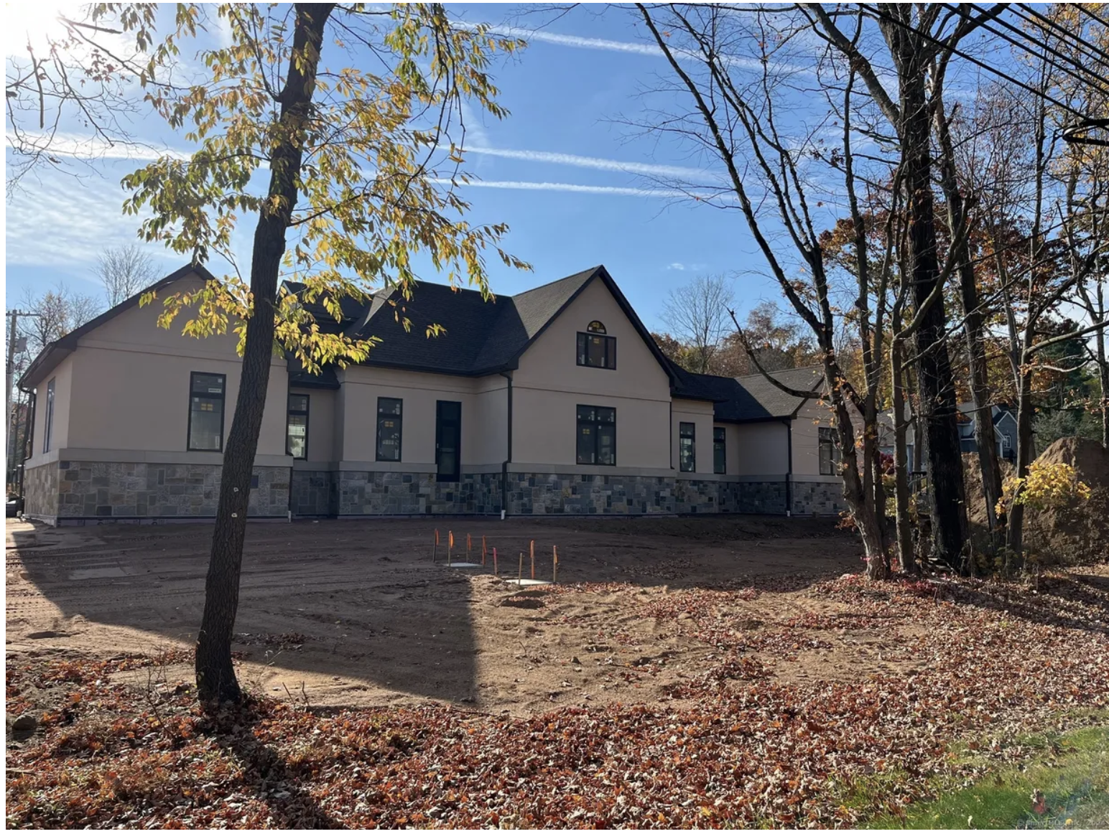

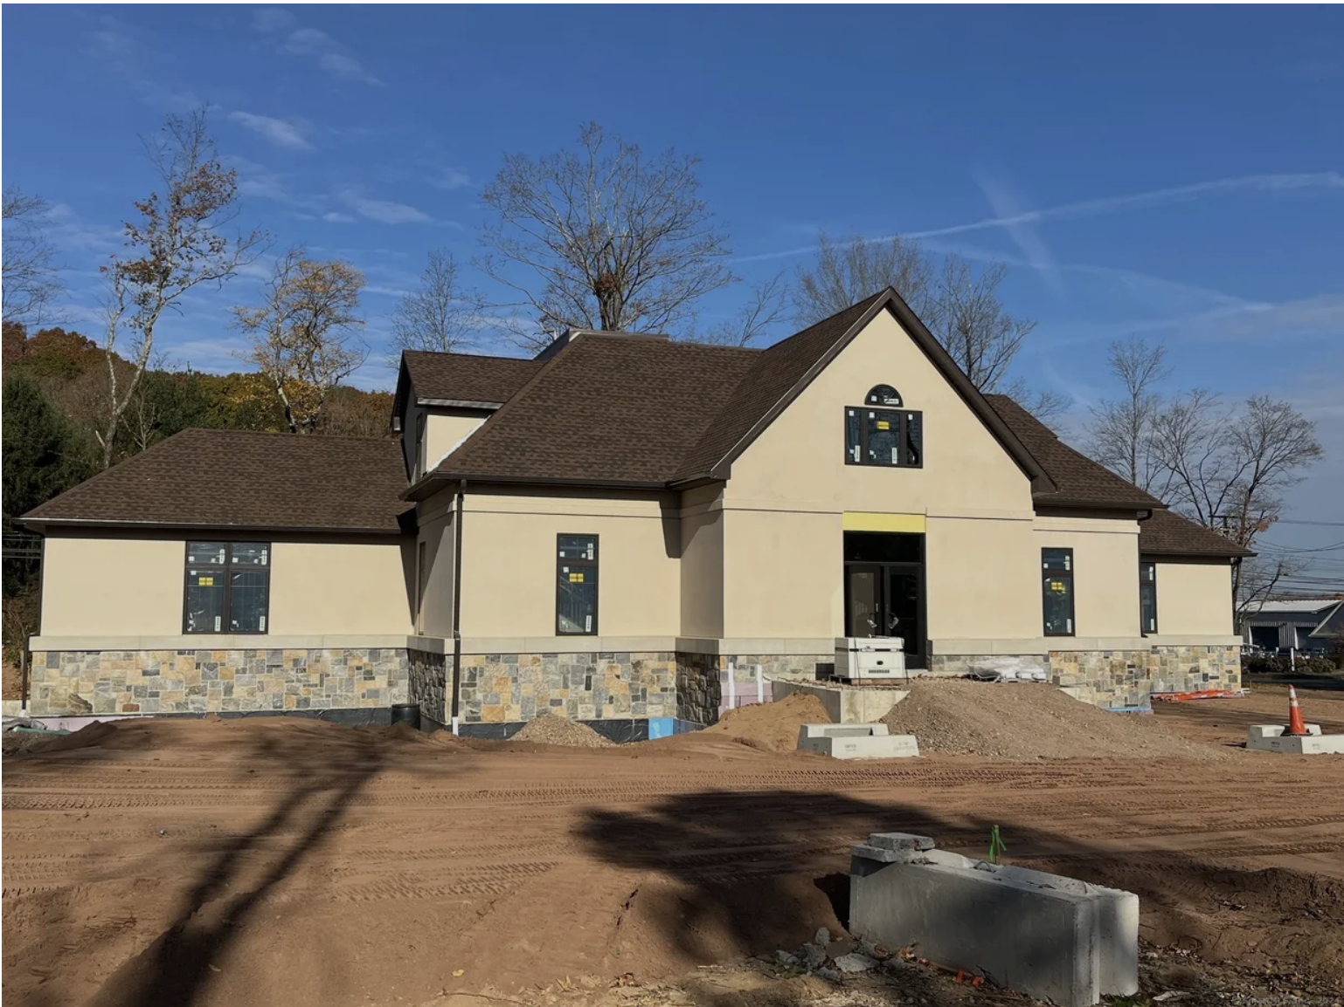

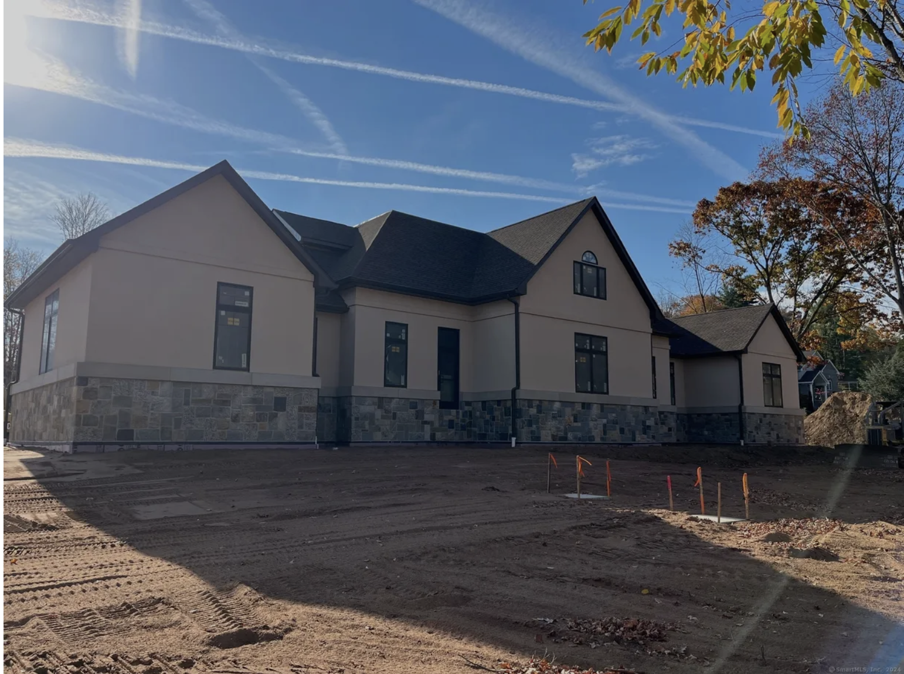

Property Overview
1003 Middletown Avenue is a newly constructed ±6,000 square foot professional office building designed to accommodate a variety of professional and medical users. The building offers flexible suite configurations and can be subdivided to accommodate multiple tenants or a single occupant.
Constructed with steel and concrete, the property features a three-stop elevator providing convenient access to all levels, including approximately ±2,400 square feet of basement space that can be utilized for additional office, storage, or operational needs.
The building sits on approximately one acre and provides parking for approximately 30 vehicles. The property includes handicap-accessible parking and EV charging stations. The modern stucco exterior with Pella windows provides both an attractive appearance and enhanced energy efficiency. Heating and cooling are supported by an energy-efficient HVAC system powered by Wallingford Electric Company.
This property offers a professional suburban setting while still providing convenient access to major regional routes and nearby business centers.

Property Highlights
• Newly constructed ±6,000 SF professional office building
• Flexible office layouts – building can be subdivided into multiple suites
• Steel and concrete construction for long-term durability
• Three-stop elevator servicing all floors
• Approximately ±2,400 SF basement level space
• Parking for approximately 30 vehicles
• ADA accessible building and parking
• EV charging stations available on-site
• Energy-efficient HVAC system through Wallingford Electric
• Modern stucco exterior with Pella windows
• Situated on approximately ±1 acre of land

Building Details
Property Type: Professional / Medical Office
Building Size: ±6,000 Square Feet
Basement Space: ±2,400 Square Feet
Lot Size: ±1 Acre
Parking: Approximately 30 Spaces
Construction: Steel & Concrete
Elevator: Three-Stop Elevator
Accessibility: ADA Compliant
Utilities: Wallingford Electric Company

Ideal Uses
This property is well suited for a variety of professional users, including:
• Medical practices
• Dental offices
• Legal offices / law firms
• Accounting firms
• Financial advisors
• Insurance agencies
• Consulting firms
• Professional service companies

Location Highlights

1003 Middletown Avenue is located in North Branford, Connecticut, offering convenient access to major roadways and surrounding communities.
• Easy access to Route 80
• Convenient connection to Interstate 95
• Approximately 15 minutes from downtown New Haven
• Located near established residential and professional neighborhoods
• Strong local professional and medical service demand
• Quiet suburban office environment with convenient regional accessibility

Parking & Site Features
• Approximately 30 on-site parking spaces
• Handicap-accessible parking spaces
• Electric vehicle charging stations
• Professionally landscaped property
• One-acre site providing ample space and accessibility

Leasing Information
For additional information or to schedule a property tour, please contact:
Phone: 203-996-4657
Or
203-640-6693

