S W I T Z E R, G O L D A U & A S S O C I A T E S

N O R M A N E. G O L D A U R E A L E S T A T E I N V E S T M E N T S T E L E P H O N E ( (6 5 0) 3 4 2 - 4 3 1 4
1201 HOWARD AVENUE, SUITE 101, BURLINGAME CA 94010 F A C S I M I L E 4 (6 5 0) 3 4 2 - 4 3 1 6

Office Space For Lease
2370 Market Street, San Francisco, CA 94114

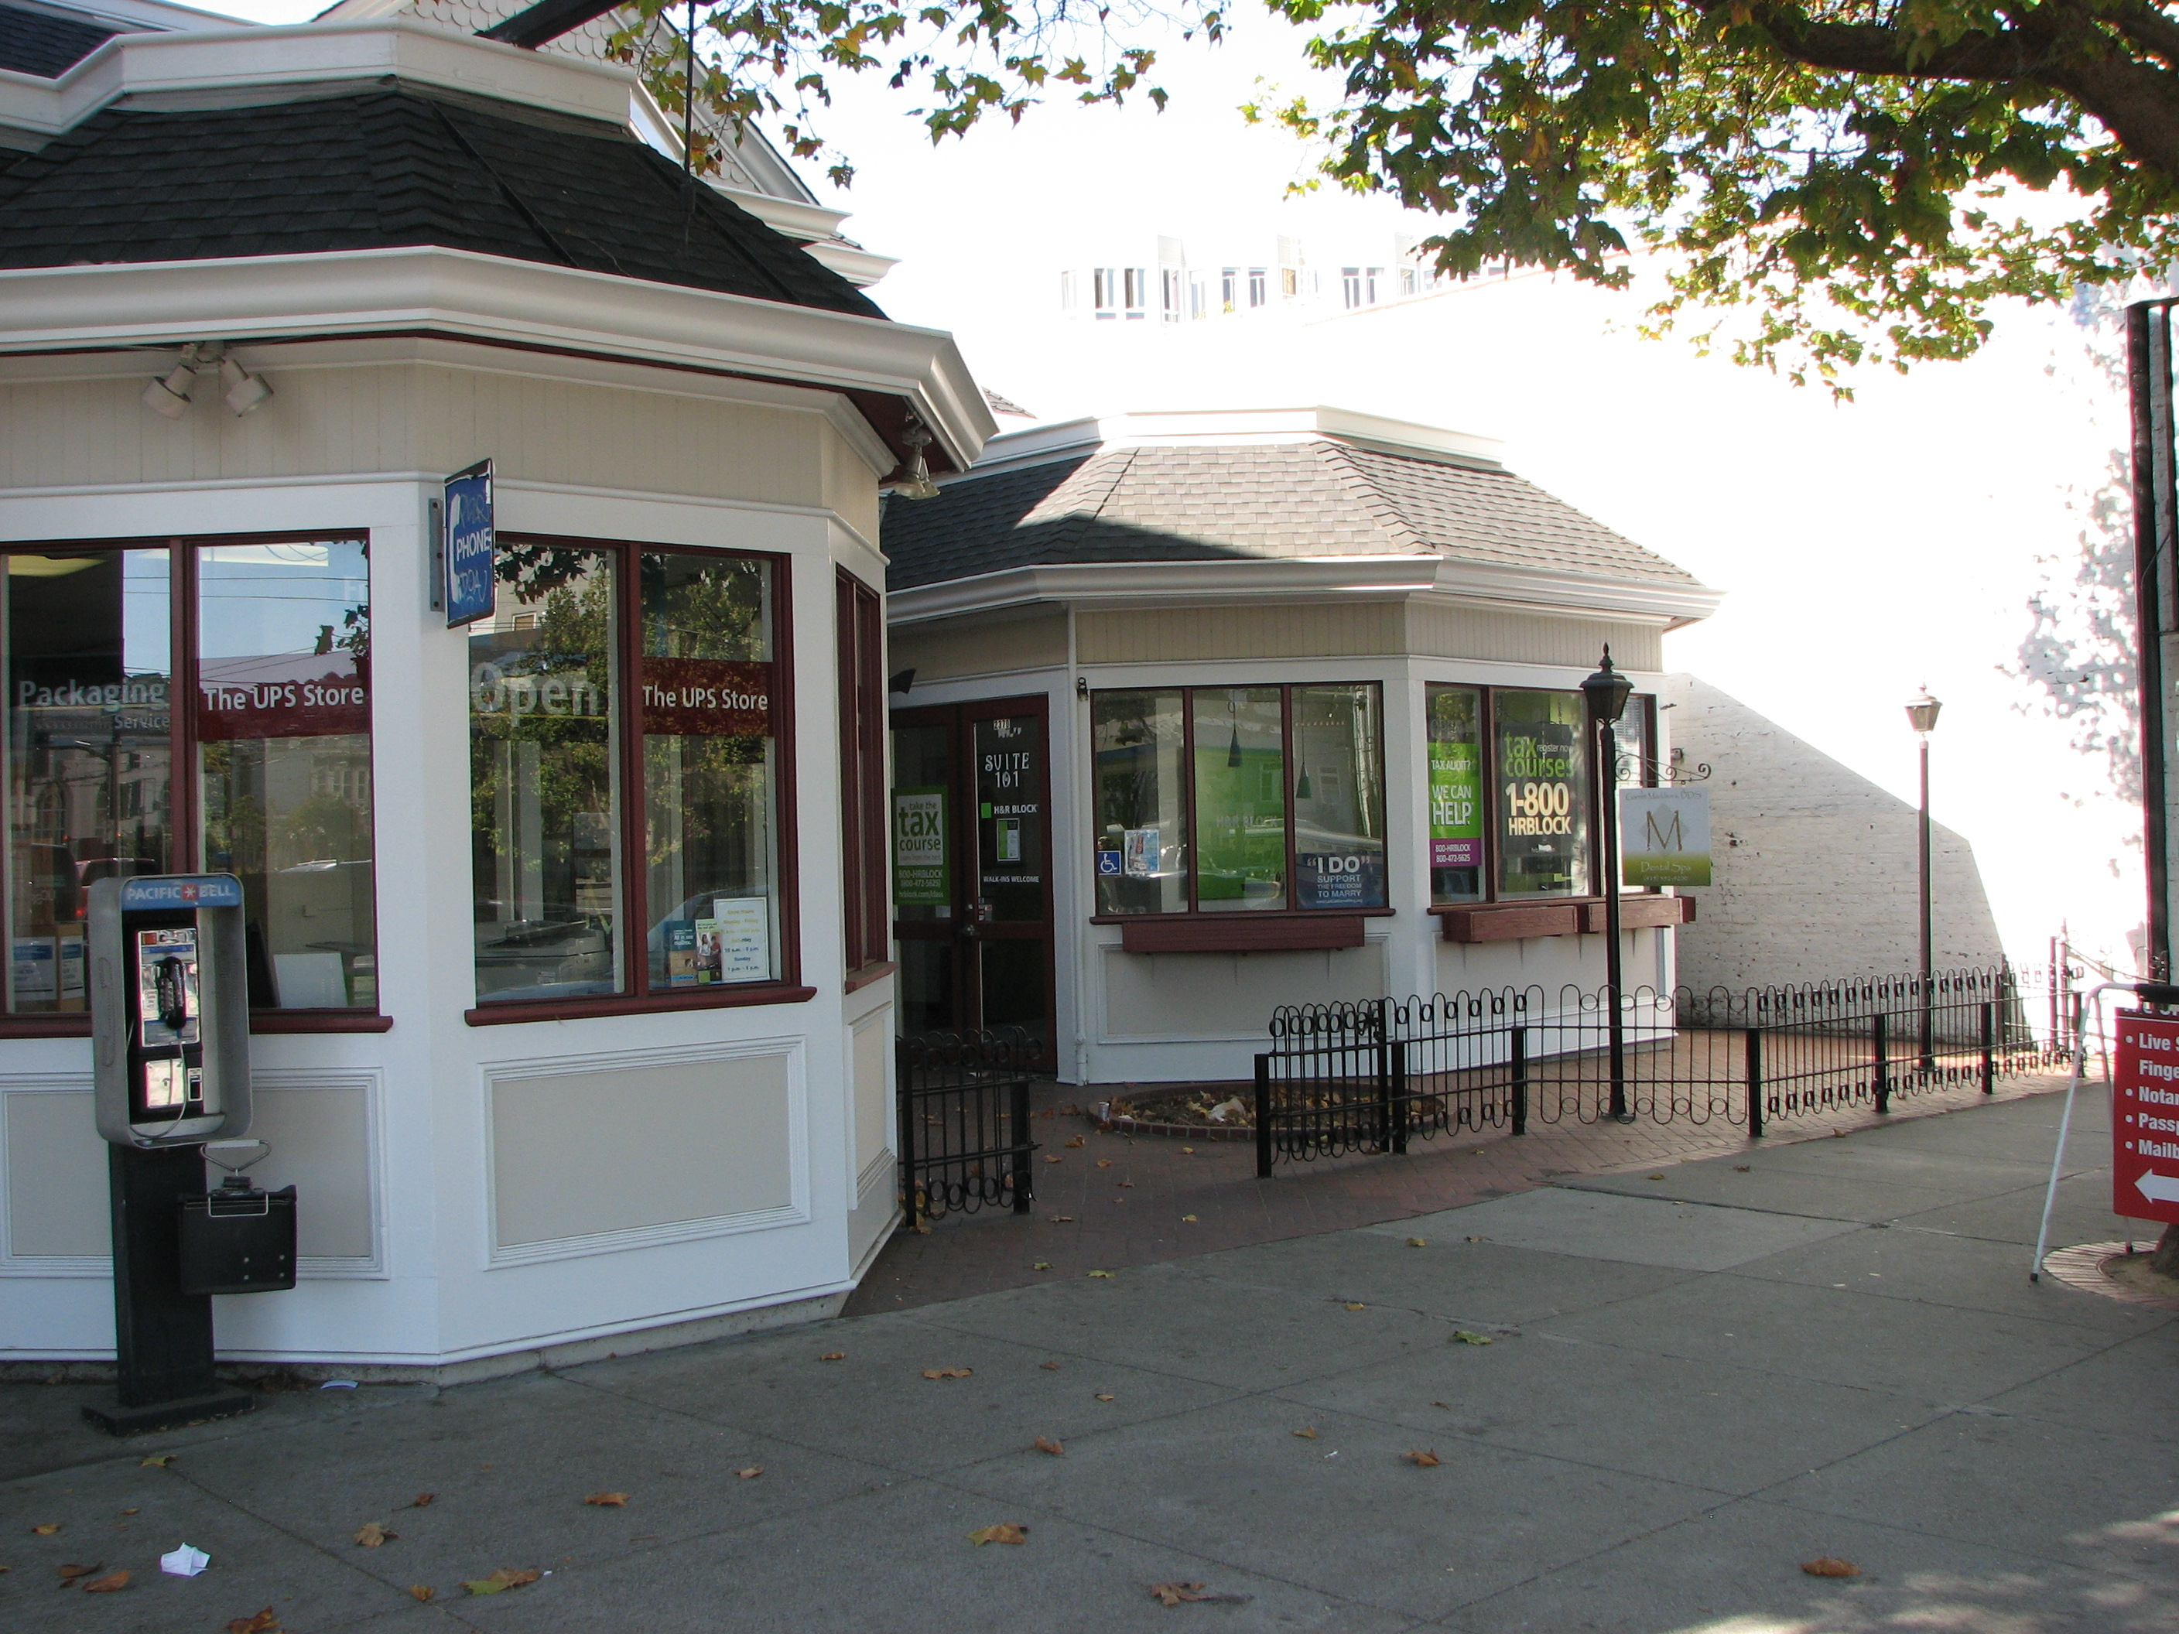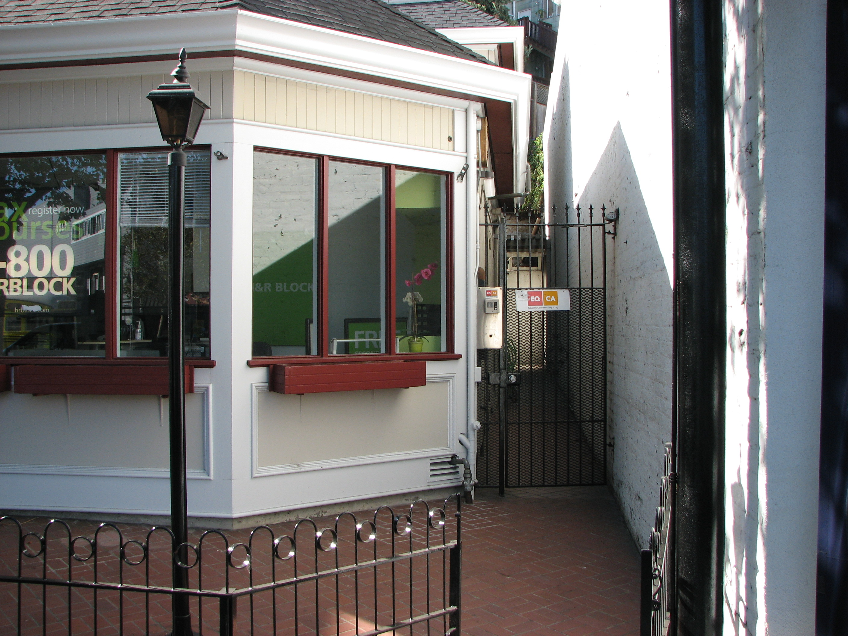

Space: 1,643 sq. ft. (approx.) of upstairs office space with a gated entrance (Market Str. Frontage) in a Victorian Retail/Commercial Building, at a prime downtown San Francisco location, near the corner of Castro & Market Streets.

Terms: 3 to 5 years lease period. Rent to be adjusted yearly by 6% minimum or CPI/All Cities Index. Options to renew possible with a fair market rent review prior to execution.

Annual Rate:
Operating expenses: Janitorial & garbage service. $ Tenant
Annual Property and Sewer Tax $ 0
Annual Rent Base Year (based on $2.00/sq.ft.) $39,432.00
Common Area Expenses/Yr.(Estimated) $ 0
Annual Costs Yr. One (Approx.) $39,432.00
Monthly Rate:
Monthly Rent: $3,286.00 or ($2.00/sq.ft. base year)
Monthly C.A.E. $ 0
Total Monthly Payment $3,286.00 (Yr. One)

Lessee must also obtain $1,000,000 business liability insurance policy & plate glass insurance.
It is the obligation of the Lessee to check with the City of San Francisco's Planning, Zoning, Bldg., Fire Dept. and other applicable City of San Francisco depts. for the purposes of any tenant improvements and intended business usage's and whether they will be approved by the City of San Francisco and the State of California.
Information deemed reliable but not guaranteed. All Quantitative and Financial Data are Approximate.

