FOR LEASE

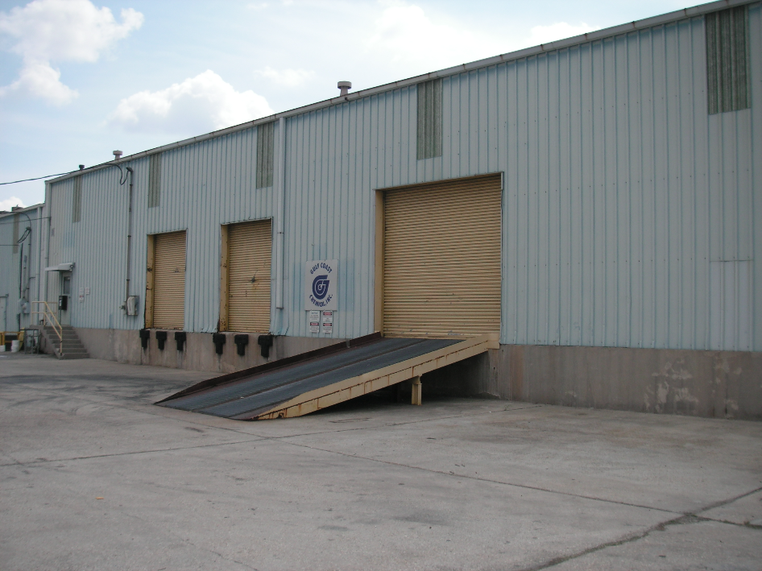

4747 River Rd. New Orleans, LA. 70121

Building: 7,000 Square Feet Eave Height: 18’

Office: 484 Square Feet Skylights: Yes

Construction: Block & Metal Sprinkler: No

Warehouse Heaters: Yes Yard Area: No

Loading: (1) 11’H x 12’W Dock Door Loading: (2) 10’H x 8’W Dock Doors

Lease Price: $3,950.00 per mo. ($6.77 psf) Net

2023 Taxes: $4,692.28 – ($391.02 per mo.) $.67 psf

2024-25 Insurance: $9,014.31 – ($751.19 per mo.) $1.29 psf

CAM: $449.91 – ($37.49 per mo.) $.06 psf

TOTAL PER MONTH: $5,129.70

Further Information: Randall Walker, SIOR
The Industrial Group
1504 L & A Road
Metairie, LA 70001
(504) 832-8012
Randall@igreal.com

Licensed By the Louisiana & Mississippi Real Estate Commissions
Licensed By The Louisiana State Licensing Board of Contractors.


7/29/26

